qPCR-graphs-7-24
Noah Krebs
2023-07-24
library(tidyverse)
## ── Attaching core tidyverse packages ──────────────────────── tidyverse 2.0.0 ──
## ✔ dplyr 1.1.2 ✔ readr 2.1.4
## ✔ forcats 1.0.0 ✔ stringr 1.5.0
## ✔ ggplot2 3.4.2 ✔ tibble 3.2.1
## ✔ lubridate 1.9.2 ✔ tidyr 1.3.0
## ✔ purrr 1.0.1
## ── Conflicts ────────────────────────────────────────── tidyverse_conflicts() ──
## ✖ dplyr::filter() masks stats::filter()
## ✖ dplyr::lag() masks stats::lag()
## ℹ Use the conflicted package (<http://conflicted.r-lib.org/>) to force all conflicts to become errors
qpcrm <- read.csv("../data/qPCR-data-7-24-1.csv", header = TRUE)
ggplot(data = qpcrm, mapping = aes(x = Subgroup, y = CqMean)) + geom_boxplot() +
facet_wrap('Target') +
coord_cartesian(ylim = c(0, 45))
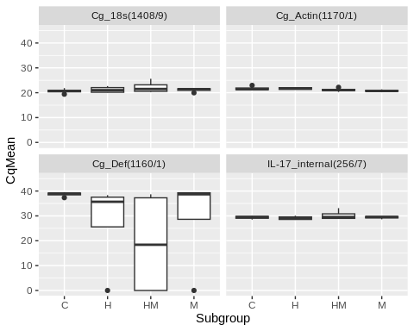
qpcrm %>%
filter(Target == "Cg_18s(1408/9)") %>%
ggplot(mapping = aes(x = Subgroup, y = CqMean)) +
geom_boxplot() +
geom_jitter(aes(color = History), width = 0.1, alpha = 0.7)
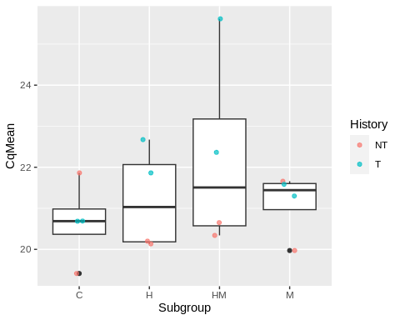
qpcrm %>%
filter(Target == "Cg_Actin(1170/1)") %>%
ggplot(mapping = aes(x = Subgroup, y = CqMean)) +
geom_boxplot() +
geom_jitter(aes(color = History), width = 0.1, alpha = 0.7)
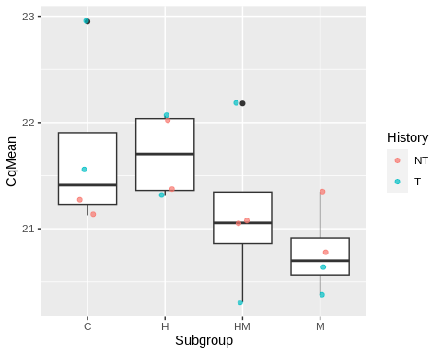
qpcrm %>%
filter(Target == "Cg_Def(1160/1)") %>%
ggplot(mapping = aes(x = Subgroup, y = CqMean)) +
geom_boxplot() +
geom_jitter(aes(color = History), width = 0.1, alpha = 0.7)
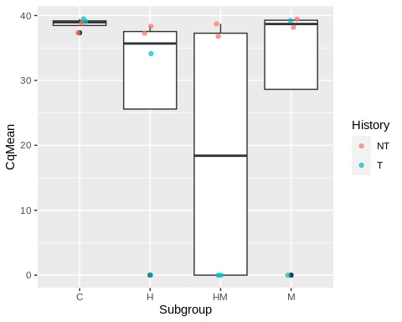
qpcrm %>%
filter(Target == "IL-17_internal(256/7)") %>%
ggplot(mapping = aes(x = Subgroup, y = CqMean)) +
geom_boxplot() +
geom_jitter(aes(color = History), width = 0.1, alpha = 0.7)
