AEV-graphs
Noah Krebs
2023-07-25
library(tidyverse)
## ── Attaching core tidyverse packages ──────────────────────── tidyverse 2.0.0 ──
## ✔ dplyr 1.1.2 ✔ readr 2.1.4
## ✔ forcats 1.0.0 ✔ stringr 1.5.0
## ✔ ggplot2 3.4.2 ✔ tibble 3.2.1
## ✔ lubridate 1.9.2 ✔ tidyr 1.3.0
## ✔ purrr 1.0.1
## ── Conflicts ────────────────────────────────────────── tidyverse_conflicts() ──
## ✖ dplyr::filter() masks stats::filter()
## ✖ dplyr::lag() masks stats::lag()
## ℹ Use the conflicted package (<http://conflicted.r-lib.org/>) to force all conflicts to become errors
qpcra <- read.csv("../data/qPCR-data-7-24-1-aev.csv", header = TRUE)
qpcrb <- read.csv("../data/qPCR-data-21-aev.csv", header = TRUE)
qpcrc <- read.csv("../data/qPCRdata-21-4-AEV.csv", header = TRUE)
qpcra %>%
filter(Target == "Cg_18s(1408/9)") %>%
ggplot(mapping = aes(x = Subgroup, y = AEV)) +
geom_boxplot() +
geom_jitter(aes(color = History), width = 0.1, alpha = 0.7)
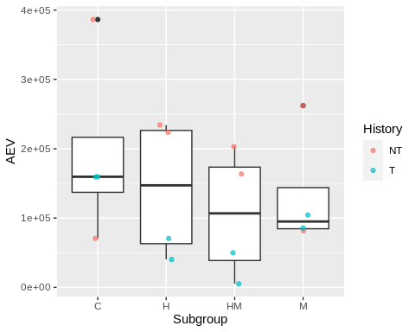
qpcra %>%
filter(Target == "Cg_Actin(1170/1)") %>%
ggplot(mapping = aes(x = Subgroup, y = AEV)) +
geom_boxplot() +
geom_jitter(aes(color = History), width = 0.1, alpha = 0.7)
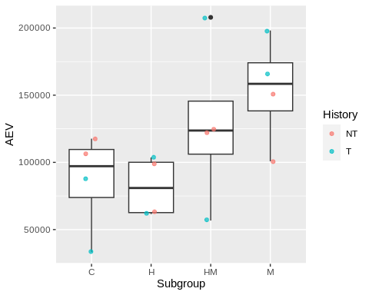
qpcra %>%
filter(Target == "Cg_Def(1160/1)") %>%
ggplot(mapping = aes(x = Subgroup, y = AEV)) +
geom_boxplot() +
geom_jitter(aes(color = History), width = 0.1, alpha = 0.7)
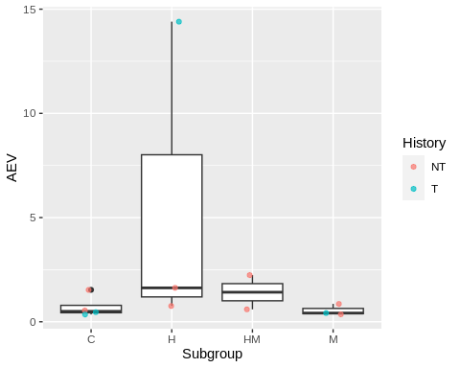
qpcra %>%
filter(Target == "IL-17_internal(256/7)") %>%
ggplot(mapping = aes(x = Subgroup, y = AEV)) +
geom_boxplot() +
geom_jitter(aes(color = History), width = 0.1, alpha = 0.7)
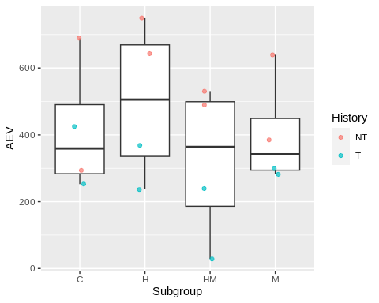
qpcrb %>%
filter(Target == "Cg_HSP70(598/9)") %>%
ggplot(mapping = aes(x = Subgroup, y = AEV)) +
geom_boxplot() +
geom_jitter(aes(color = History), width = 0.1, alpha = 0.7)
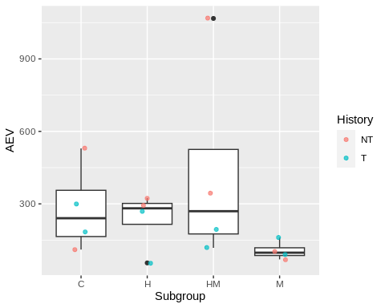
qpcrb %>%
filter(Target == "Cg_HSP90(1532/3)") %>%
ggplot(mapping = aes(x = Subgroup, y = AEV)) +
geom_boxplot() +
geom_jitter(aes(color = History), width = 0.1, alpha = 0.7)
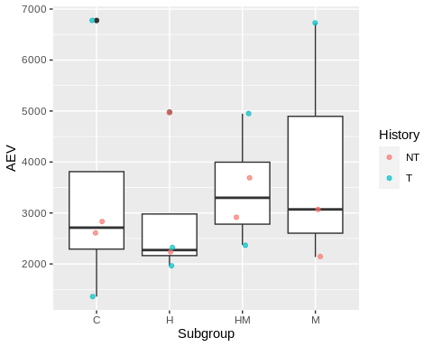
qpcrb %>%
filter(Target == "Cg_VIPERIN(1828/9)") %>%
ggplot(mapping = aes(x = Subgroup, y = AEV)) +
geom_boxplot() +
geom_jitter(aes(color = History), width = 0.1, alpha = 0.7)
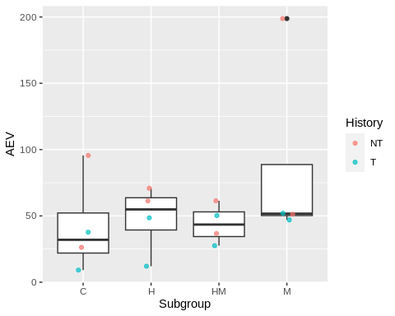
qpcrc %>%
filter(Target == "Cg_18s(1408/9)") %>%
ggplot(mapping = aes(x = Subgroup, y = AEV)) +
geom_boxplot() +
geom_jitter(aes(color = History), width = 0.1, alpha = 0.7)
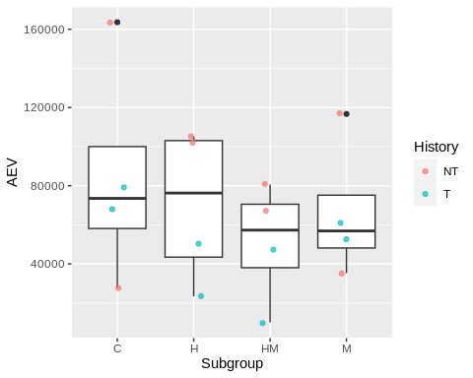
qpcrc %>%
filter(Target == "Cg_ATPsynthase(1385/6)") %>%
ggplot(mapping = aes(x = Subgroup, y = AEV)) +
geom_boxplot() +
geom_jitter(aes(color = History), width = 0.1, alpha = 0.7)
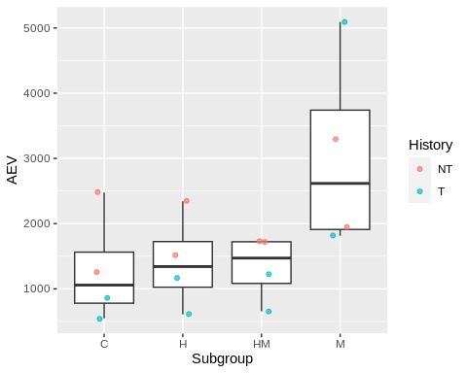
qpcrc %>%
filter(Target == "Cg_citratesynthase(1383/4)") %>%
ggplot(mapping = aes(x = Subgroup, y = AEV)) +
geom_boxplot() +
geom_jitter(aes(color = History), width = 0.1, alpha = 0.7)
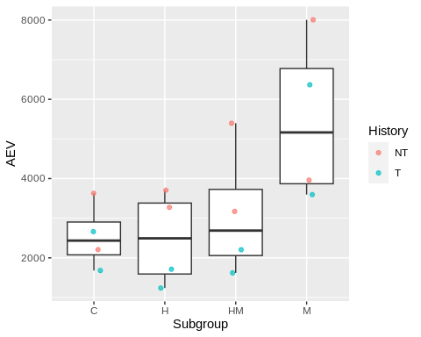
qpcrc %>%
filter(Target == "Cg_GAPDH(1172/3)") %>%
ggplot(mapping = aes(x = Subgroup, y = AEV)) +
geom_boxplot() +
geom_jitter(aes(color = History), width = 0.1, alpha = 0.7)
