​​

Figure S1. Representative Barcode Rank Plots

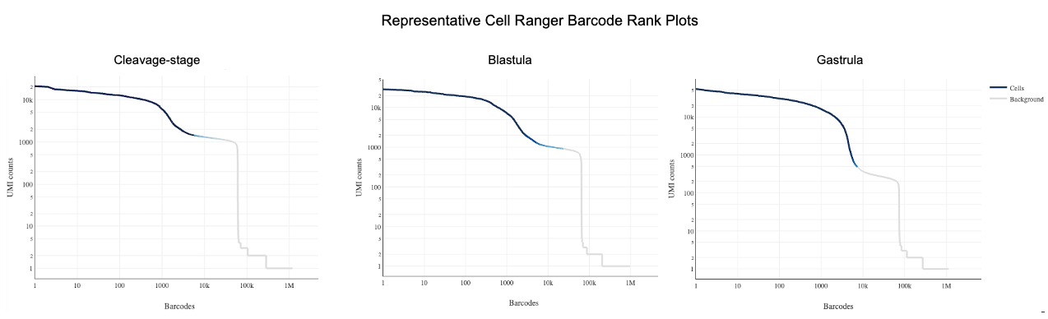

Figure S2. Genes associated with PGCs in oyster gastrulae are not specifically expressed in cleavage + blastula clusters. Dot plot illustrating expression of vasa and the top 10 PGC cluster marker genes in cleavage + blastula clusters. Dot color represents expression level and dot size represents fractional representation of cells expressing a gene.

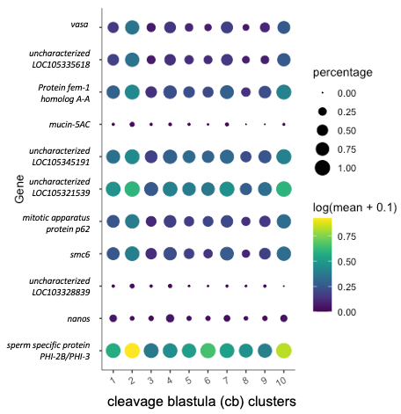

Figure S3. UMAP of neural markers not expressed at the gastrula stage in C. gigas. Expression patterns of select neural genes in UMAP space.
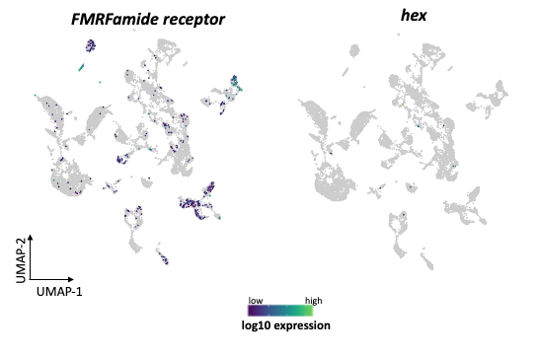

Figure S4. UMAP of cleavage + blastula cells color-coded according to library type. Colors: pooled cleavage stages (CP) and blastula (Bla).
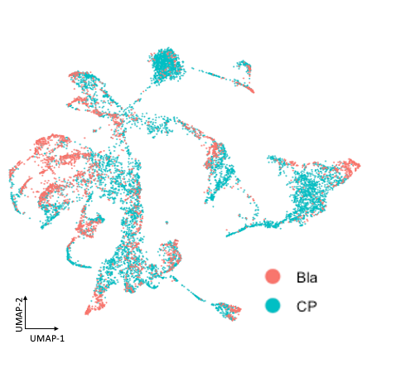

Figure S5. Cluster analysis of blastula cells visualized via UMAP. (A) UMAP plot in which cells are colored according to blastula clusters. (B) UMAP plot of cleavage-blastula cells, where cells are colored according to the blastula clusters and cells from the cleavage-stage embryos are gray.
