**Week 2: Bleached and Lesion Sand Dollar Project**

**8/3/12: Animal Collection**

Collection of animals from Ship Bay, Orcas Island. There were many sizes of sand dollars-smaller juvenille sand dollars close to the eel grass bed (which had Haminoea and Laby lesions!). It was hard to find adults that were fully “healthy” without bleaching. The bleaching was found most often at the leading edge that they use to dig into the sand and on the underside. Almost every juvenille we found had bleaching.

**8/4/12- Bleaching and lesioned sand dollars from East Sound- protocol**

* 1. Histology
     1. Two bleached, one healthy small sand dollars put in 3.5% formalin, to be transferred to EtOH, then to be decalcified and sectioned and put in cassettes.
     2. One healthy (Accession #: SB-1-H), one bleached (SB-3-B) large sand dollars internal organs (gonads, digestive tract) put in cassettes and into Davidson's fixative, to be transferred to EtOH.
        1. Observations- large bleached sand dollar was male- looked at sperm under microscope. Sex unknown for bleached.
        2. Gross morphology from dissection- bleached were easier to crack in half, somewhat more brittle test. Healthy specimens interior was clear and dark, diseased interior was cloudy and pale (fluid contained sperm after injuries to organs)
        3. [Pictures from histology and comparison]
  2. Cultures

|  |  |  |  |  |  |
| --- | --- | --- | --- | --- | --- |
| Accession # | Bleaching | Lesions | Histo? | Plates | Swab |
| SB-1-H (large) | no | No | organs | Marine Agar & TCBS | Interior and Exterior |
| SB-6-H (small) | no | no | whole individual | Marine Agar & TCBS | Exterior |
| SB-2-B | yes | no | no | Marine Agar & TCBS | Interior and Exterior |
| SB-3-B | yes | no | organs | Marine Agar & TCBS | Interior and Exterior |
| SB-4-BL | yes | yes | no | 2x Marine Agar & TCBS lesion and bleaching | Bleaching Interior and Exterior, Lesion Interior and Exterior |
| SB-5-BL | yes | yes | no | Marine Agar & TCBS | Lesion Interior and Exterior |
|  |  |  |  |  |  |

* 1. Transmission Experiment
     1. mesh sided boxes in common sea table (same water in all boxes)
     2. individuals placed touching in boxes at start
     3. new mud placed in boxes immediately prior to placement-from Argyle Lagoon collected on August 4th
     4. length is measured along the axis of symmetry of the sand dollar
     5. Will check on health of sand dollars daily
     6. Some healthy sand dollars had evidence of previous injuries or predation, but all injuries were completely healed.
     7. All extra sand dollars (all are bleached or lesioned) are being kept in separate sea table.

Tank set up (boxes labeled from previous experiment)

Transmission experiments:  
  
Setup:

|  |  |  |
| --- | --- | --- |
| Box 3: 1 bleached, 77mm 2 healthy, 51 mm, 66mm | Box 6: 1 bleached, 89mm 2 healthy, 46mm, 68mm | Box 2: Healthy babies, 22mm, 31mm, 30mm |
| Box 8: 3 healthy, 48mm, 71mm, 74mm *Larger dollars had predation | Box 13: 1 bleached, 66mm 2 healthy, 72mm, 67mm | Box 4: Bleached babies, 29mm, 30mm, 26mm |
| Box 16: 1 bleached, 89 mm 2 healthy, 46mm, 68 mm | Box 10: 3 healthy, 72mm, 49mm, 54mm | Empty |

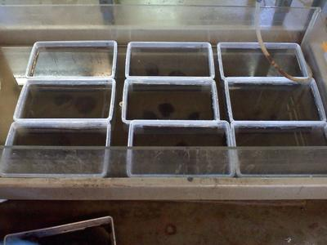

Swab and culture:  
H = healthy  
B = bleached  
L = lesions  
  
TCBS (media specific for *Vibrios*)  
  
SB-1-H: Inside/Outside  
SB-5-BL: Inside/Outside  
SB-3-B: Inside/Outside  
SB-4-BL: Inside/Outside of bleached area  
SB-4-BL: Inside/Outside of lesioned area  
SB-2-B: Inside/Outside  
SB-6-H: Inside/Outside  
  
Marine Agar (generic media for bacteria)  
SB-4-BL: Outside  
SB-1-H: Inside/Outside  
SB-3-B: Inside/Outside  
SB-5-BL: Inside/Outside lesions  
SB-4-BL: Inside/Outside bleached  
SB-6-H: Outside  
SB-2-B: Inside/Outside  
  
Future steps could include: isolating cultured bacteria from single colonies and ran 3 times to fully isolate a bacteria individually, followed by sequencing to identify bacteria.

**8/5/12: 24 hours of growth**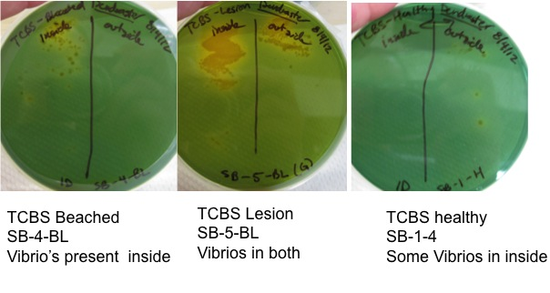

Here are some of the TCBS plates after 24 hours of growth. The yellow coloration indicates that we have *Vibrio*s present in the streak. It’s interesting that there are 2 colonies growing in the inside of the healthy one, and a lot inside the bleached and lesion individuals. The insides of these animals should be *Vibrio* free. We noticed in the field that it was hard to find fully healthy individuals. Maybe our “healthy” individual wasn’t fully healthy (?)

There are many colonies growing on the nutrient broth plates in natural seawater.

Transmission Experiment Progress:  
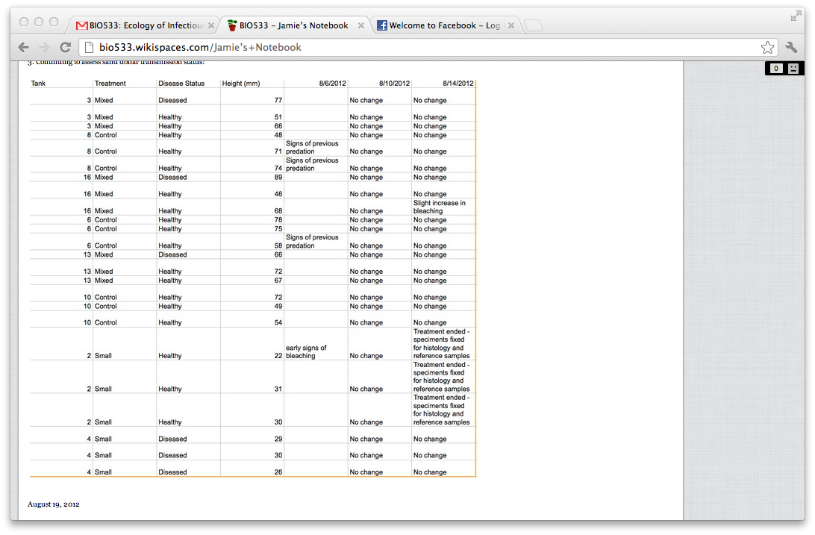

Histology Decalcification notes  
  
Sol A: 25 grams sodium citrate (citric acid) in 250 mL dI water  
  
Sol B: 60 mL 90% formic acid in 120 mL dI water  
  
  
-OR-  
  
  
57 mL 95% formic acid in 123 mL dI water  
  
*Tips  
1. Wash organism with tap water before beginning (~5), can dissolve in cassette  
2. Need to use glass F-ware  
3. Use lid but do not screw shut so gas can escape  
4. Shake every few hours or put bottles on shaker to homogenize acid  
5. Add acid to water (sodium citrate) not water (sodium citrate) to acid. Very important!!!!  
6. Switch solution every few hours/when bubbling stops  
7. Put cassettes in EtOH afterwards (not Davidson's)  
  
We used 75mL solution A + 25mL solution B