7/24/12.  Invertebrate Dissections

* Urchin dissection**-**

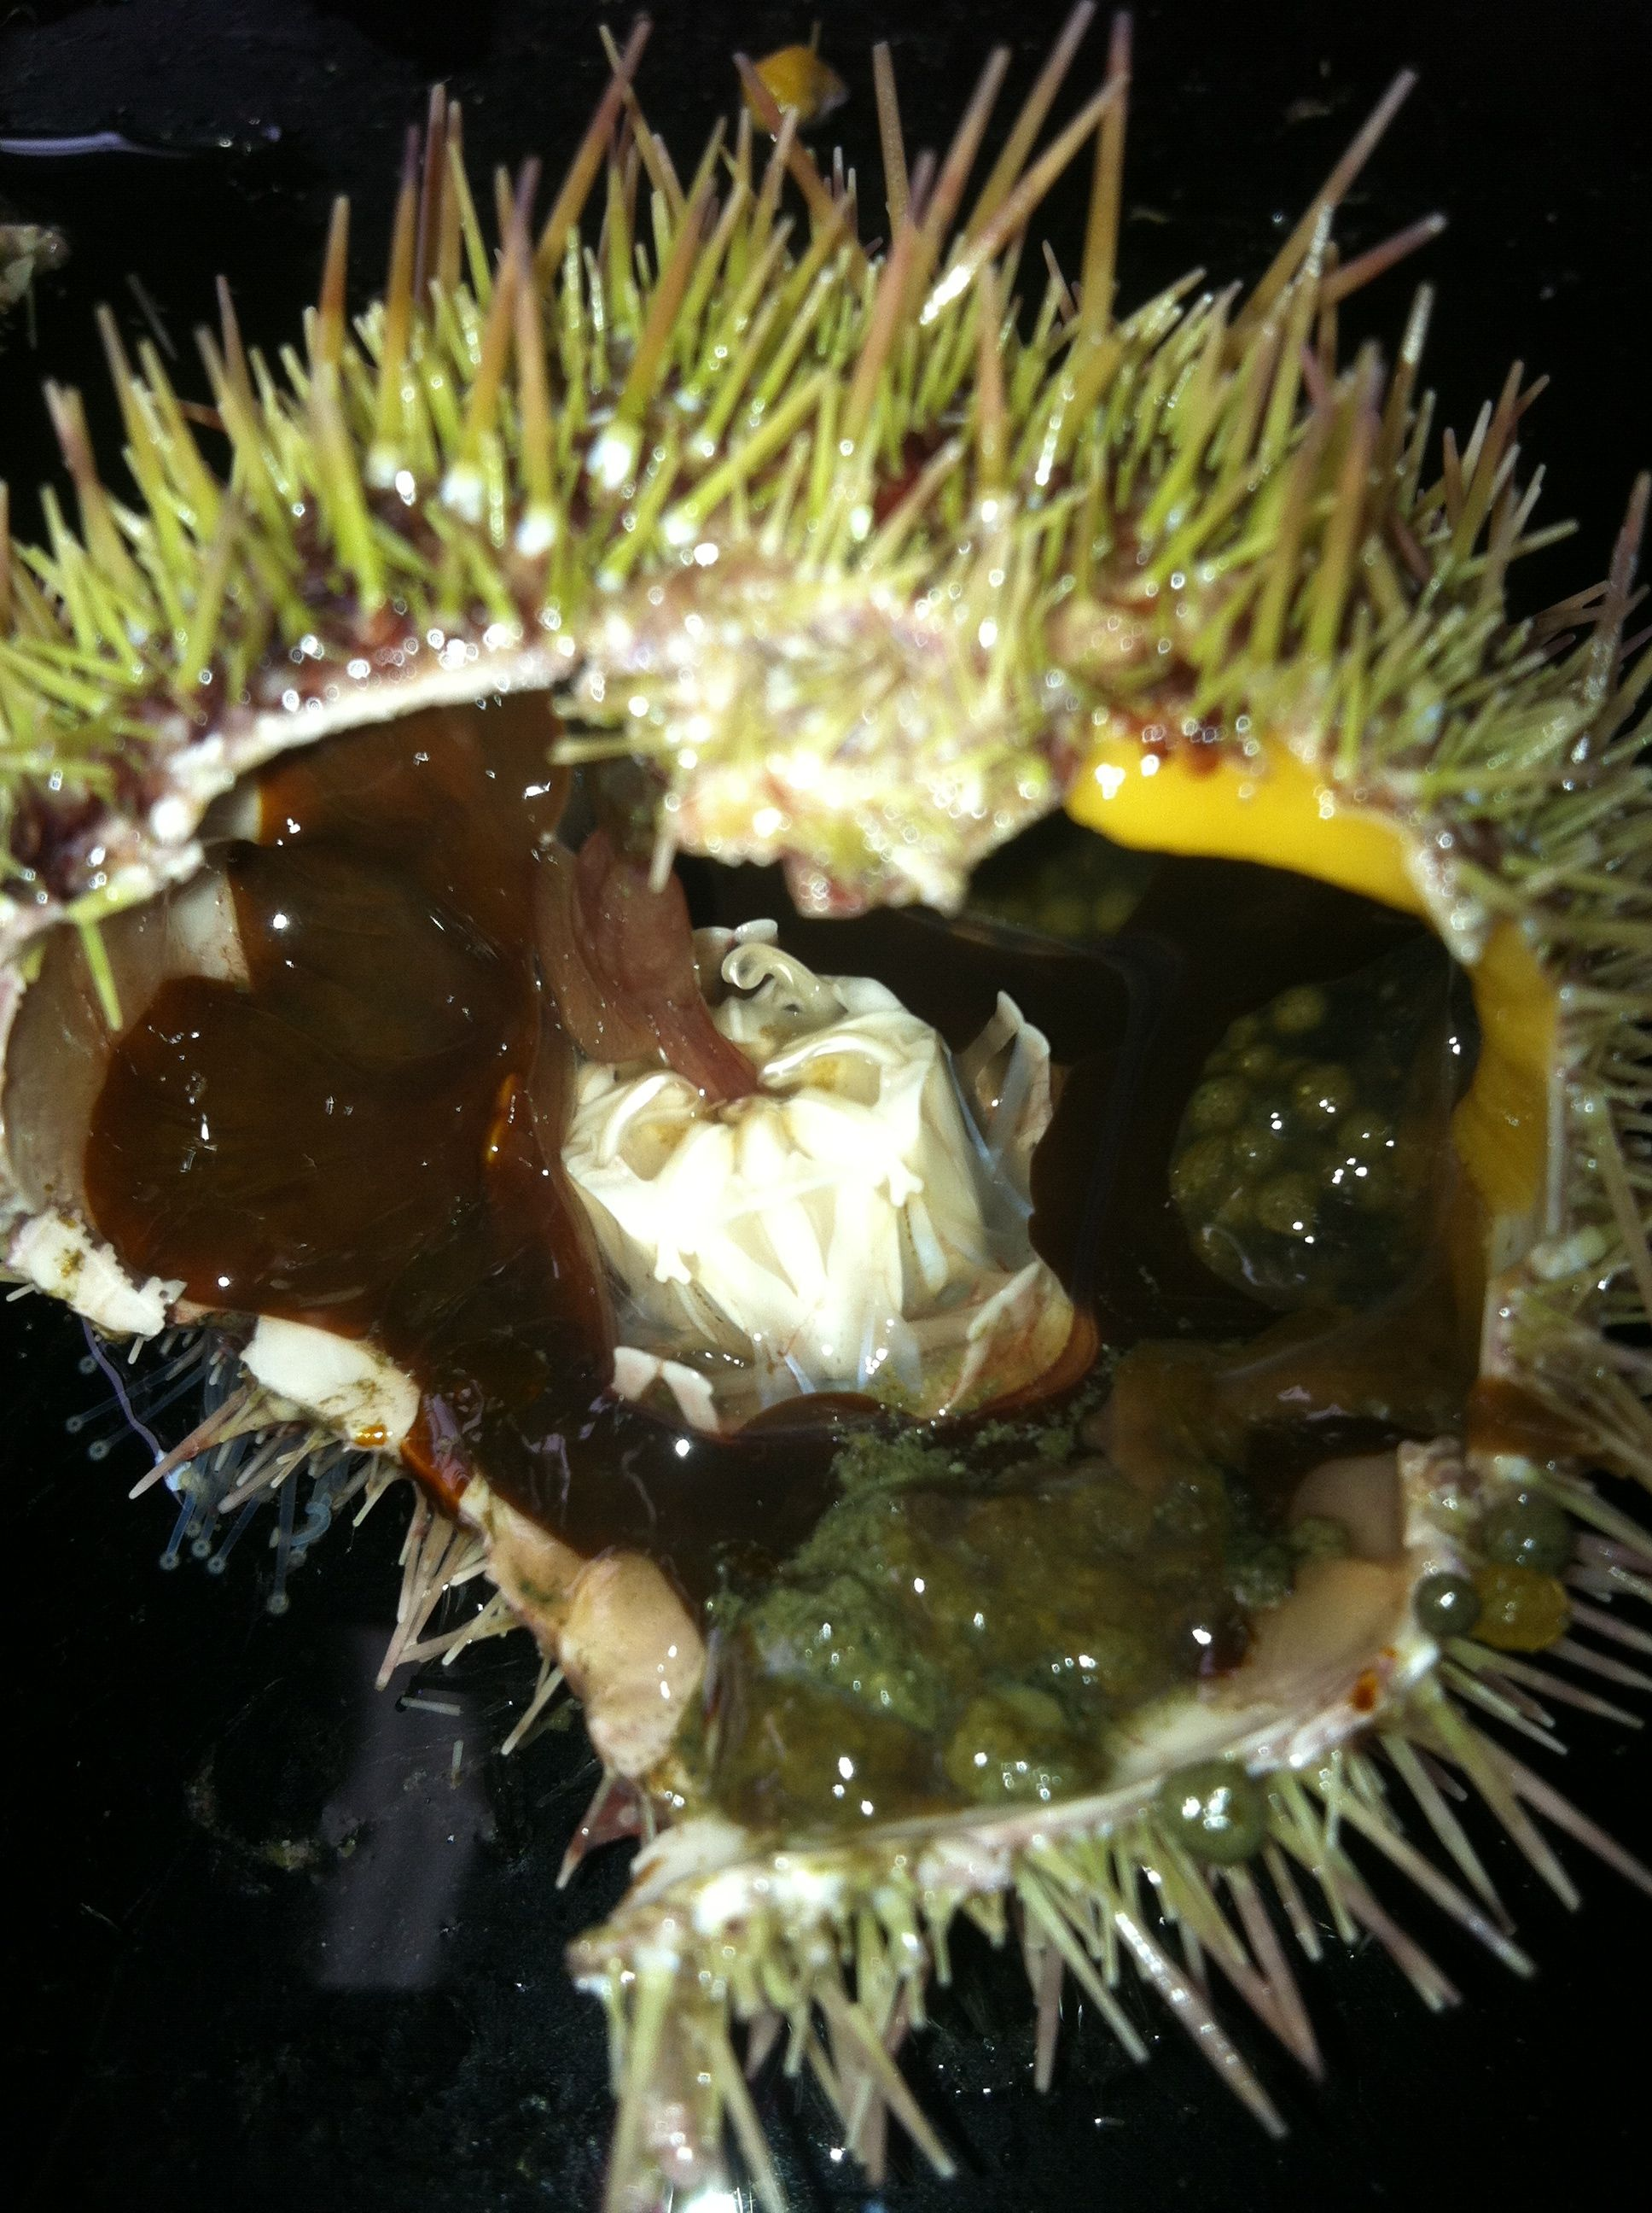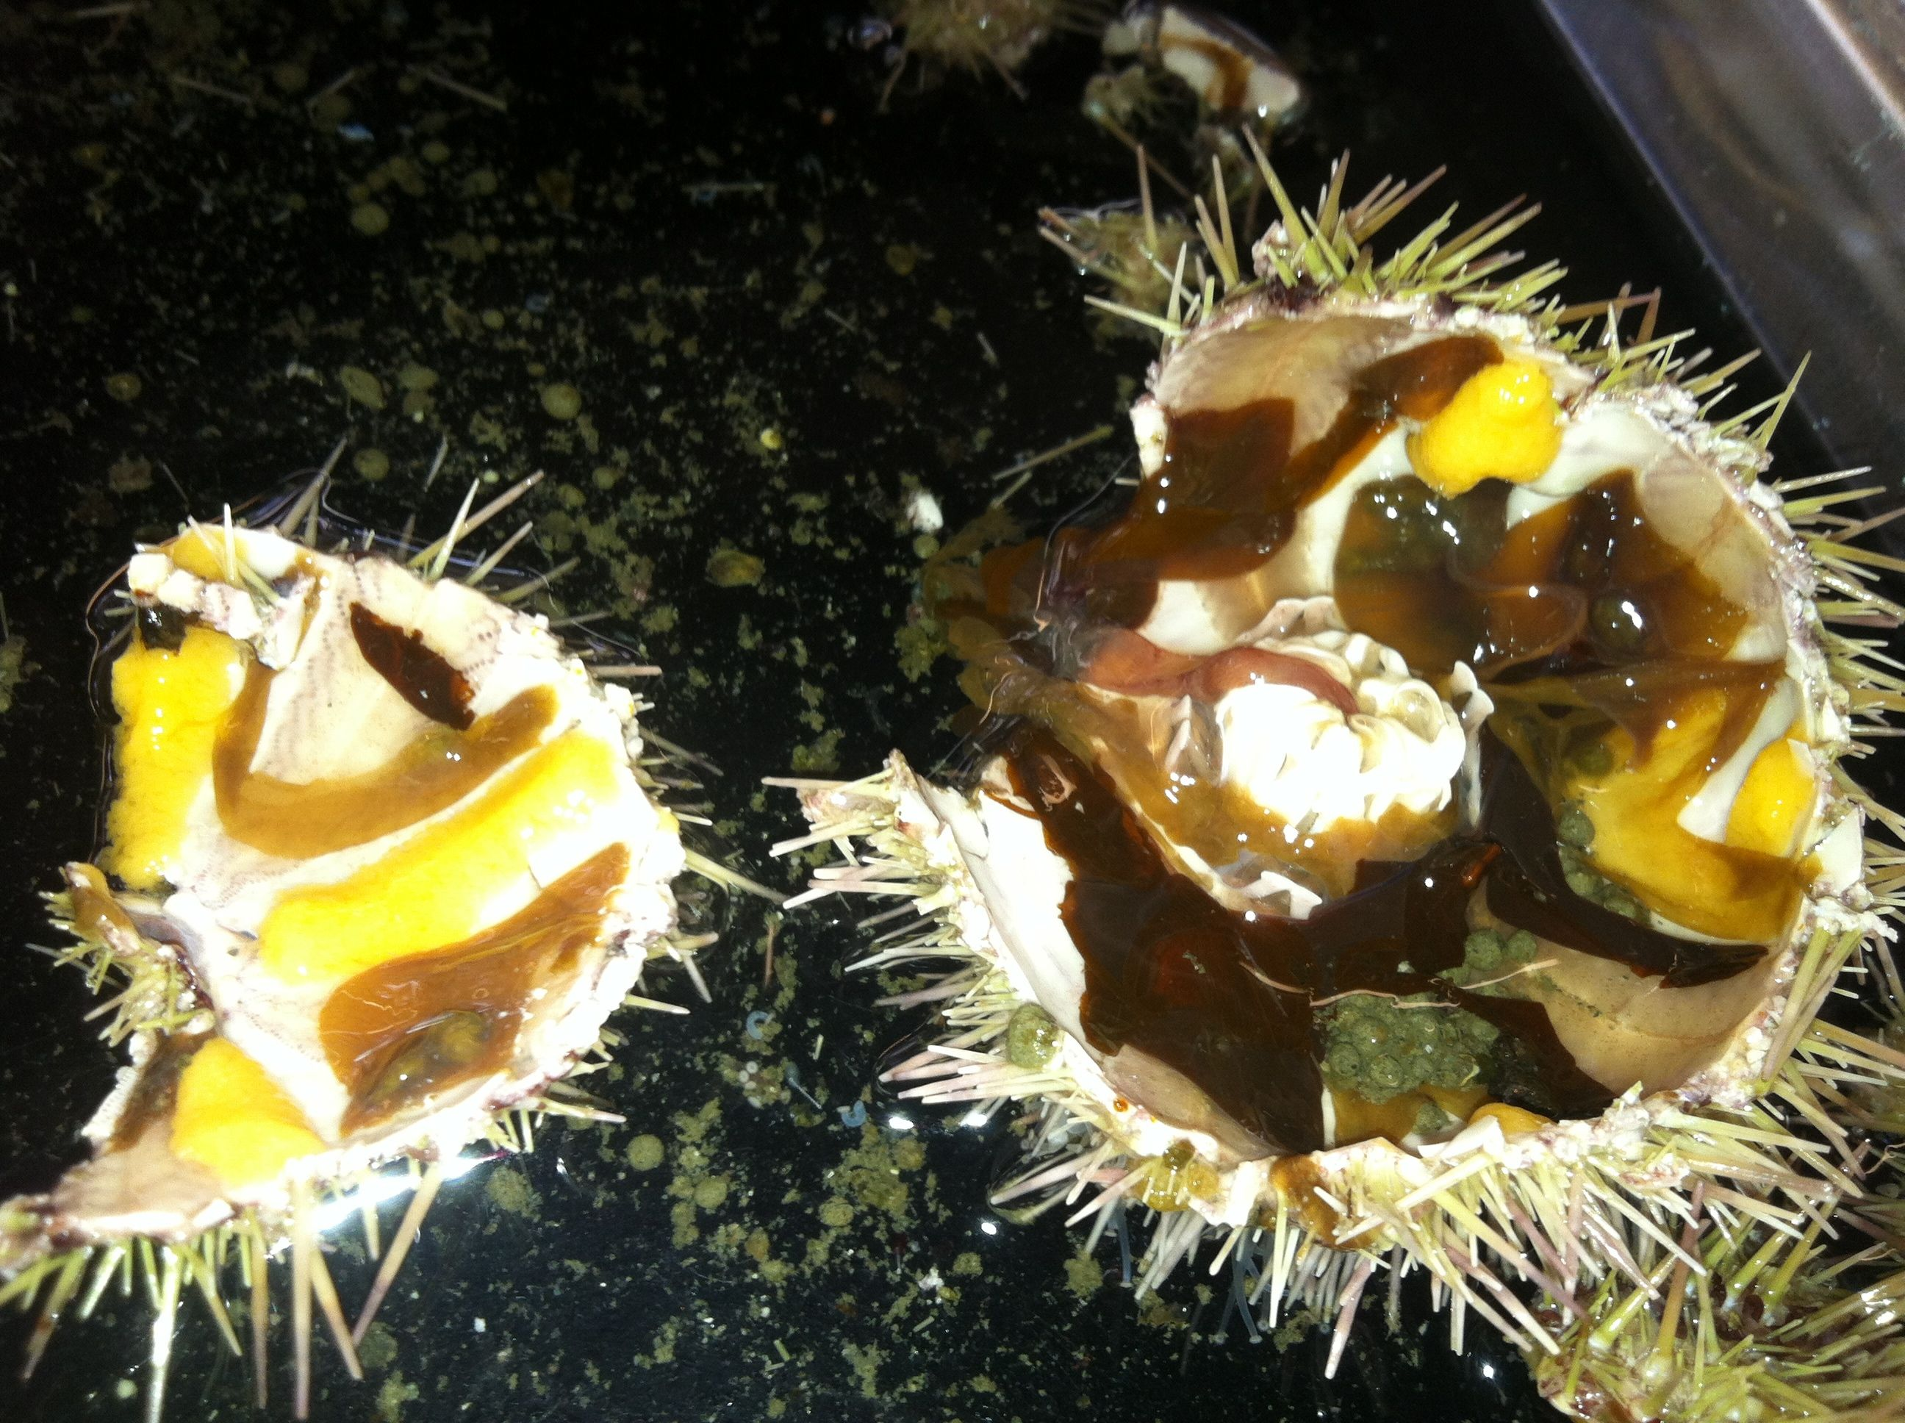

* + Aristotle's lantern image
  + Slides- mesentary and gonads
    - brown tissue=connective tissue
    - protozoans swimming in tissue but most likely from seawater
* sea cucumber dissection
  + started cutting and all the insides were spit out! (we started cutting from the wrong end to start)
  + gonads on anterior end-white and stringy
  + clear respiratory trees and orange-clear intestine
  + unidentified neon orange tubules attached to digestive system
  + with opened body cavity can see longitudinal and circular muscles very clearly
  + cloacal dialator muscles still moving after cut and ring canal removed
  + polian vesicle inflated when attached to ring canal, deflated after it was cut
* oyster dissection
  + oysters live in LEFT side of shell
  + to dissect, unhinge (shuck like eating oyster) but cut adductor muscle before prying open
  + cross section

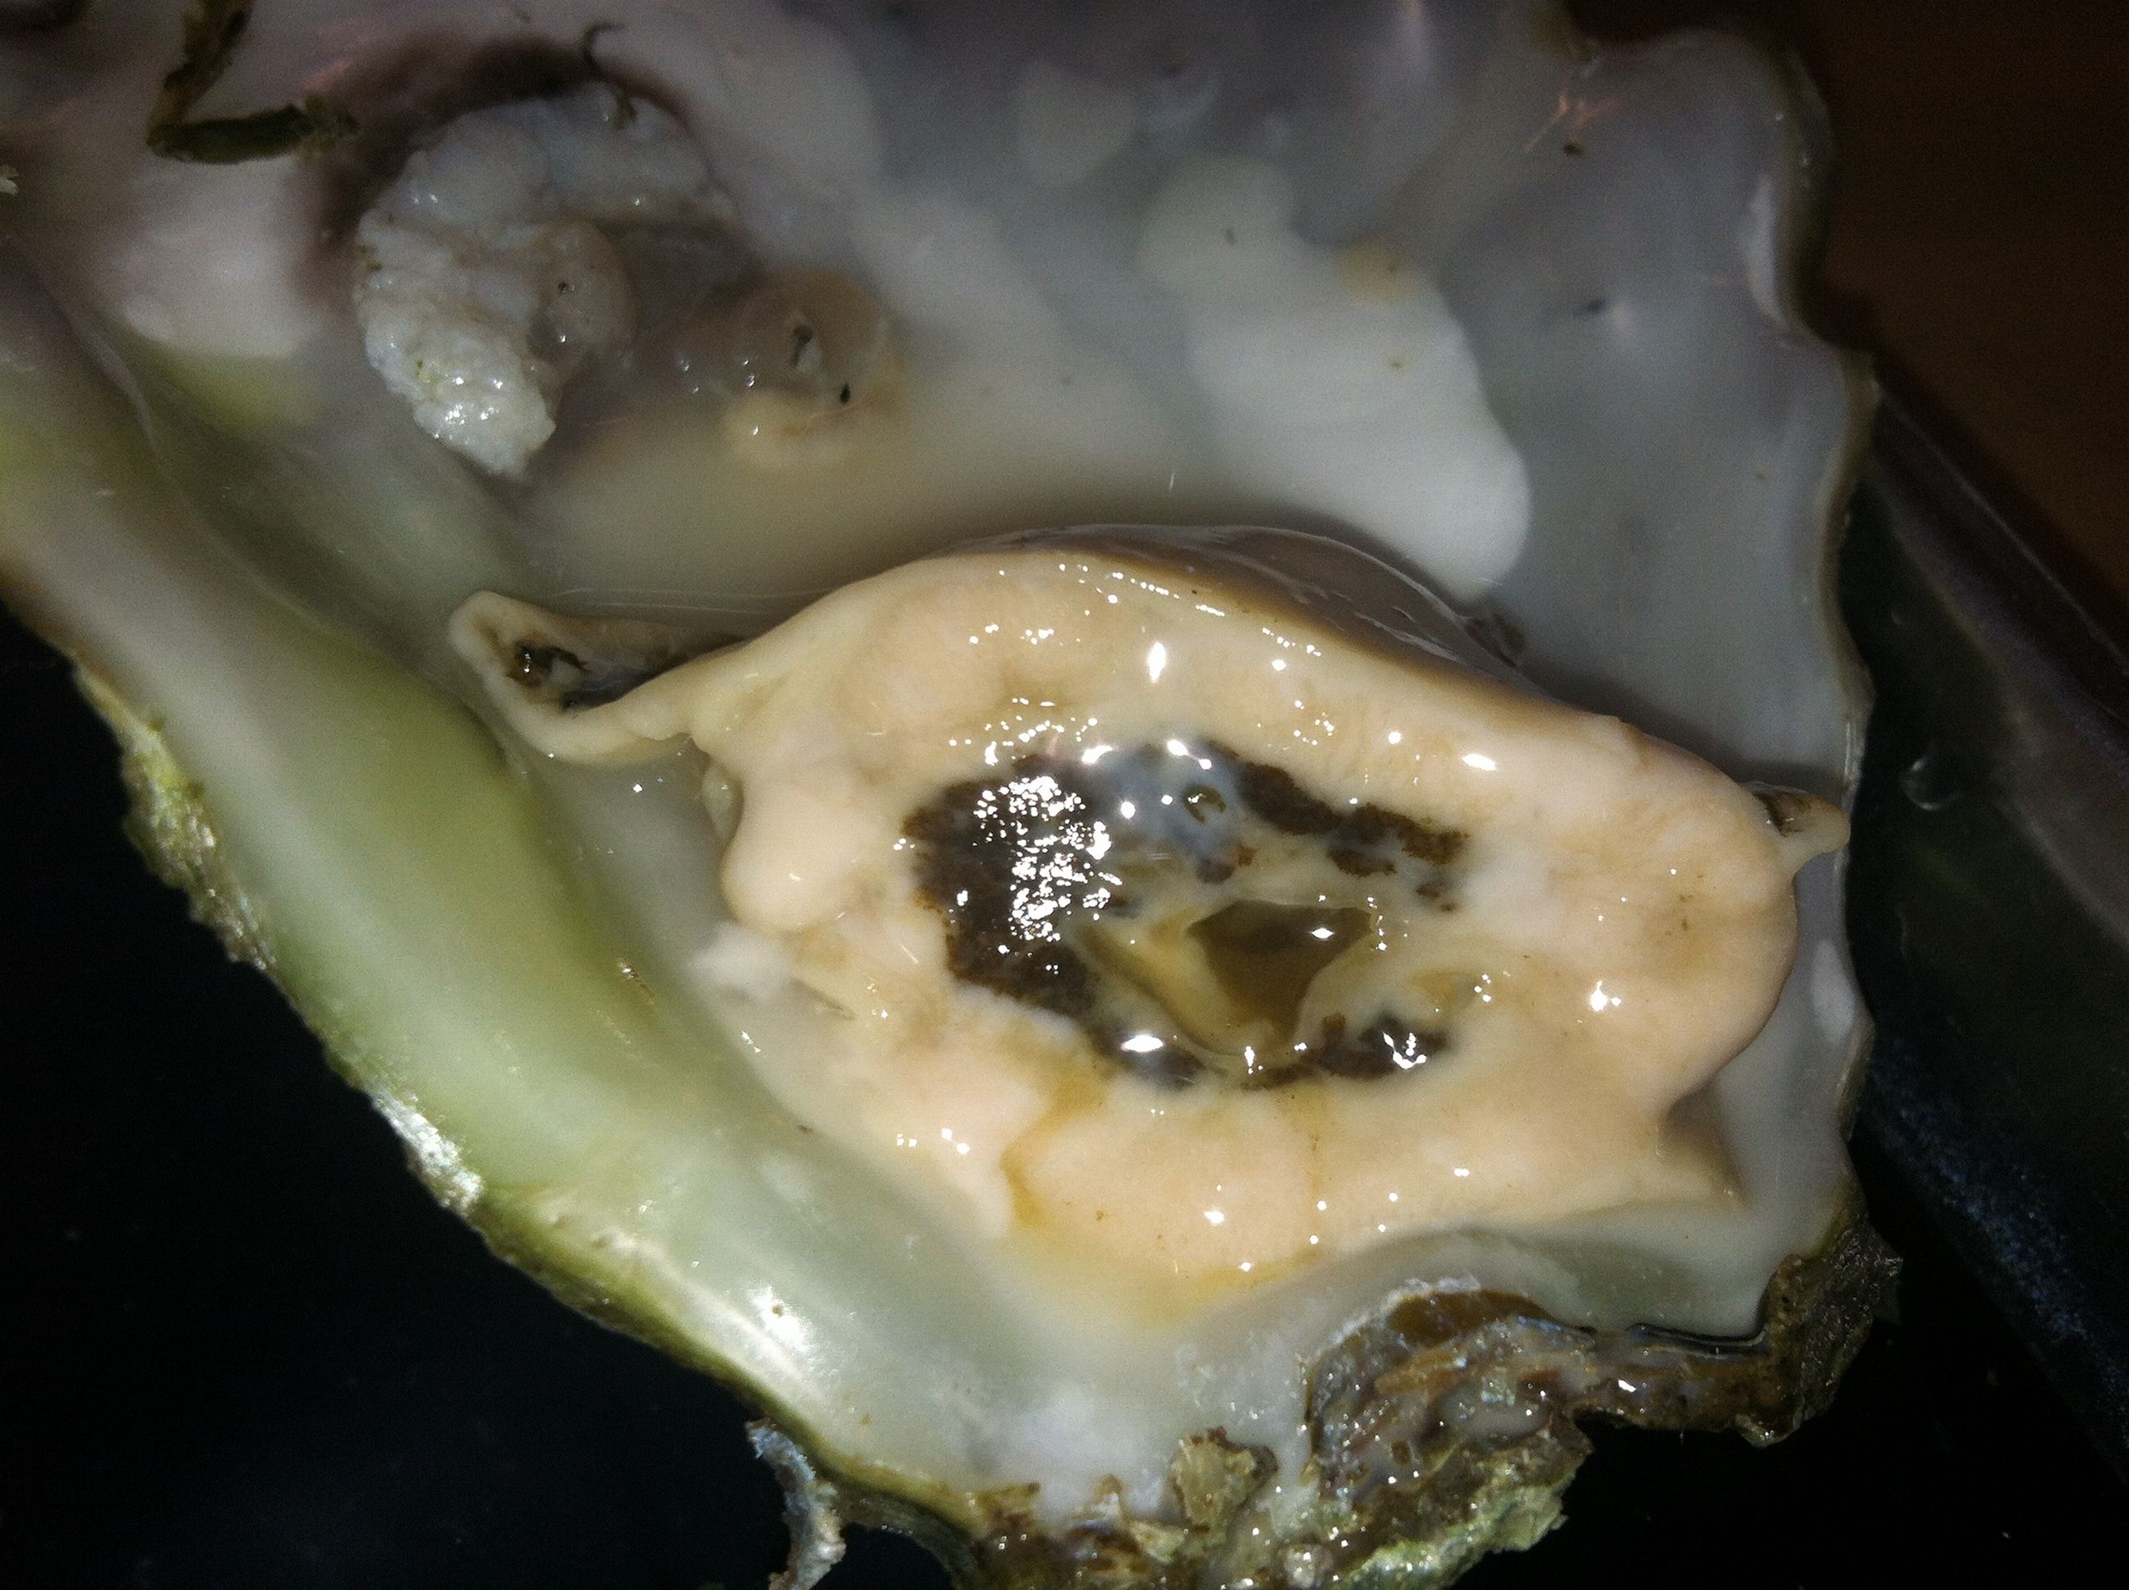

* shrimp dissection
* 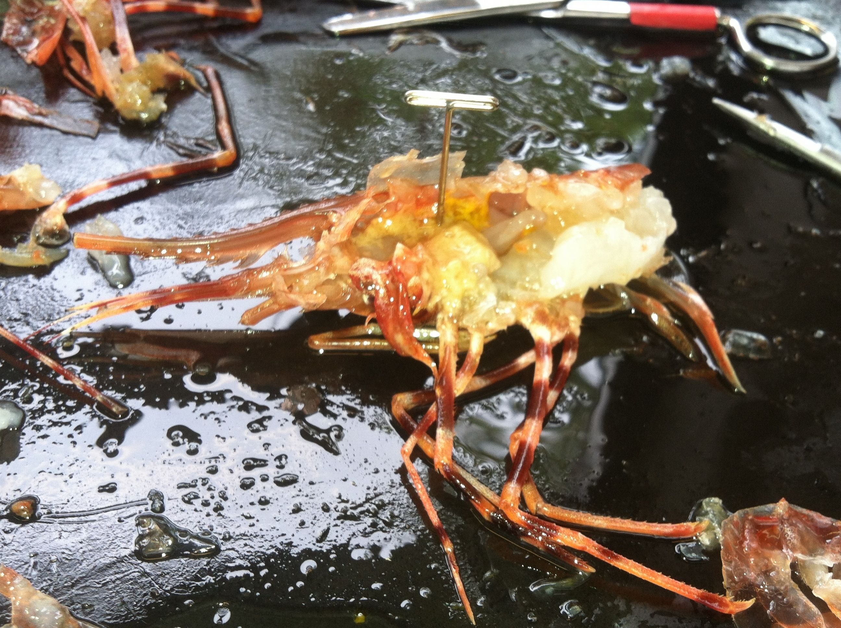
* nucella dissection
* seastar dissection

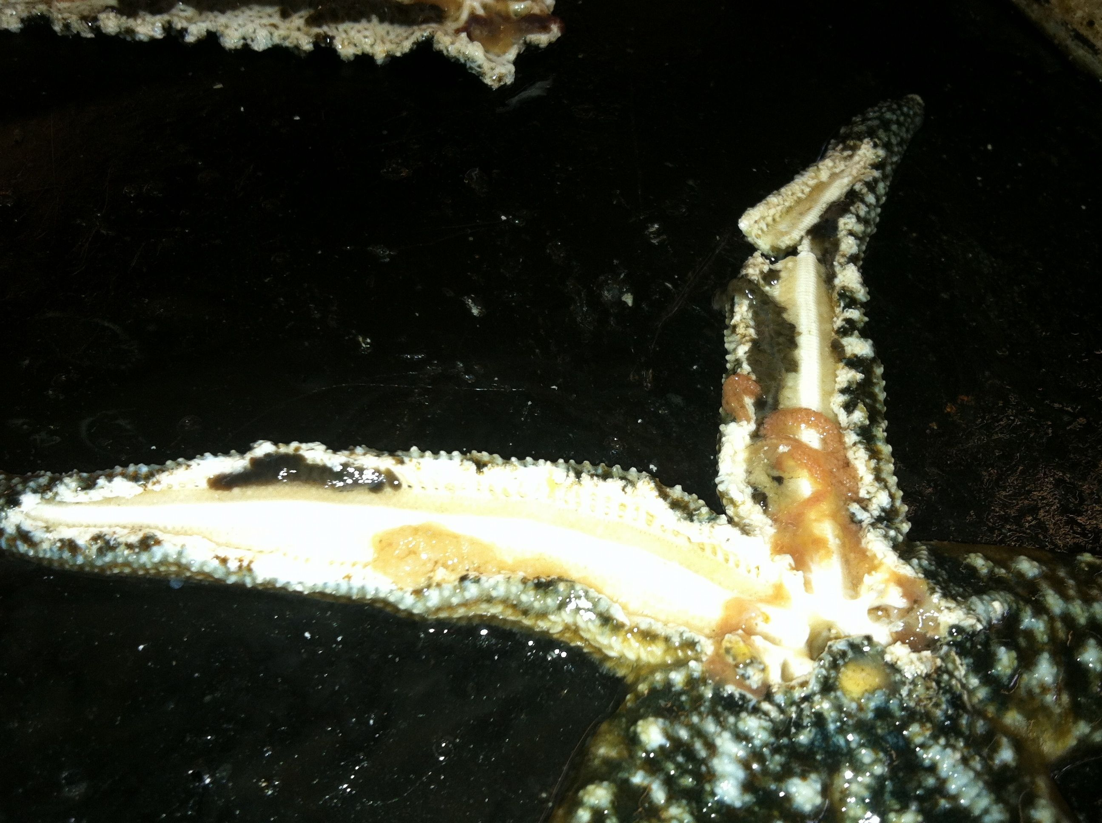

Histology lab. Looking through different sets of normal and diseased organisms

* need to be familiar with normal tissue composition by species and be able to identify diseases
  + abalone
  + bivalves-batman shaped intestine
  + shrimp
  + finfish
* Table of diseases, pathogen, target tissue, histology

*Armina* Dissection

* Armina samples given from Jim Murray (CSU-East Bay)
  + Samples have brains removed for their neurobiology research

|  |  |  |  |
| --- | --- | --- | --- |
| Name | Accession # | Total Length (mm) | Total weight (g) |
| Lisa | 12-1-1 | 42 | 4.7 |
| Lisa | 12-1-2 | 56.5 | 5.5 |
| Amy | 12-1-3 | 43.6 | 5.6 |
| Jamie | 12-1-4 | 36.7 | 3.2 |
| Jenna | 12-1-5 | 36.4 | 4.3 |
| Annie | 12-1-6 | 41 | 4.3 |
| Gregor | 12-1-7 | 57.7 | 8.6 |

* Notes on sample **12-1-3**
  + Dorsal- pink lesion on back (image)
  + Ventral-2 dark spots-anterior and bottom left (image)
    - Dark spots are surrounded by lighter dark spots, especially the one in the head region

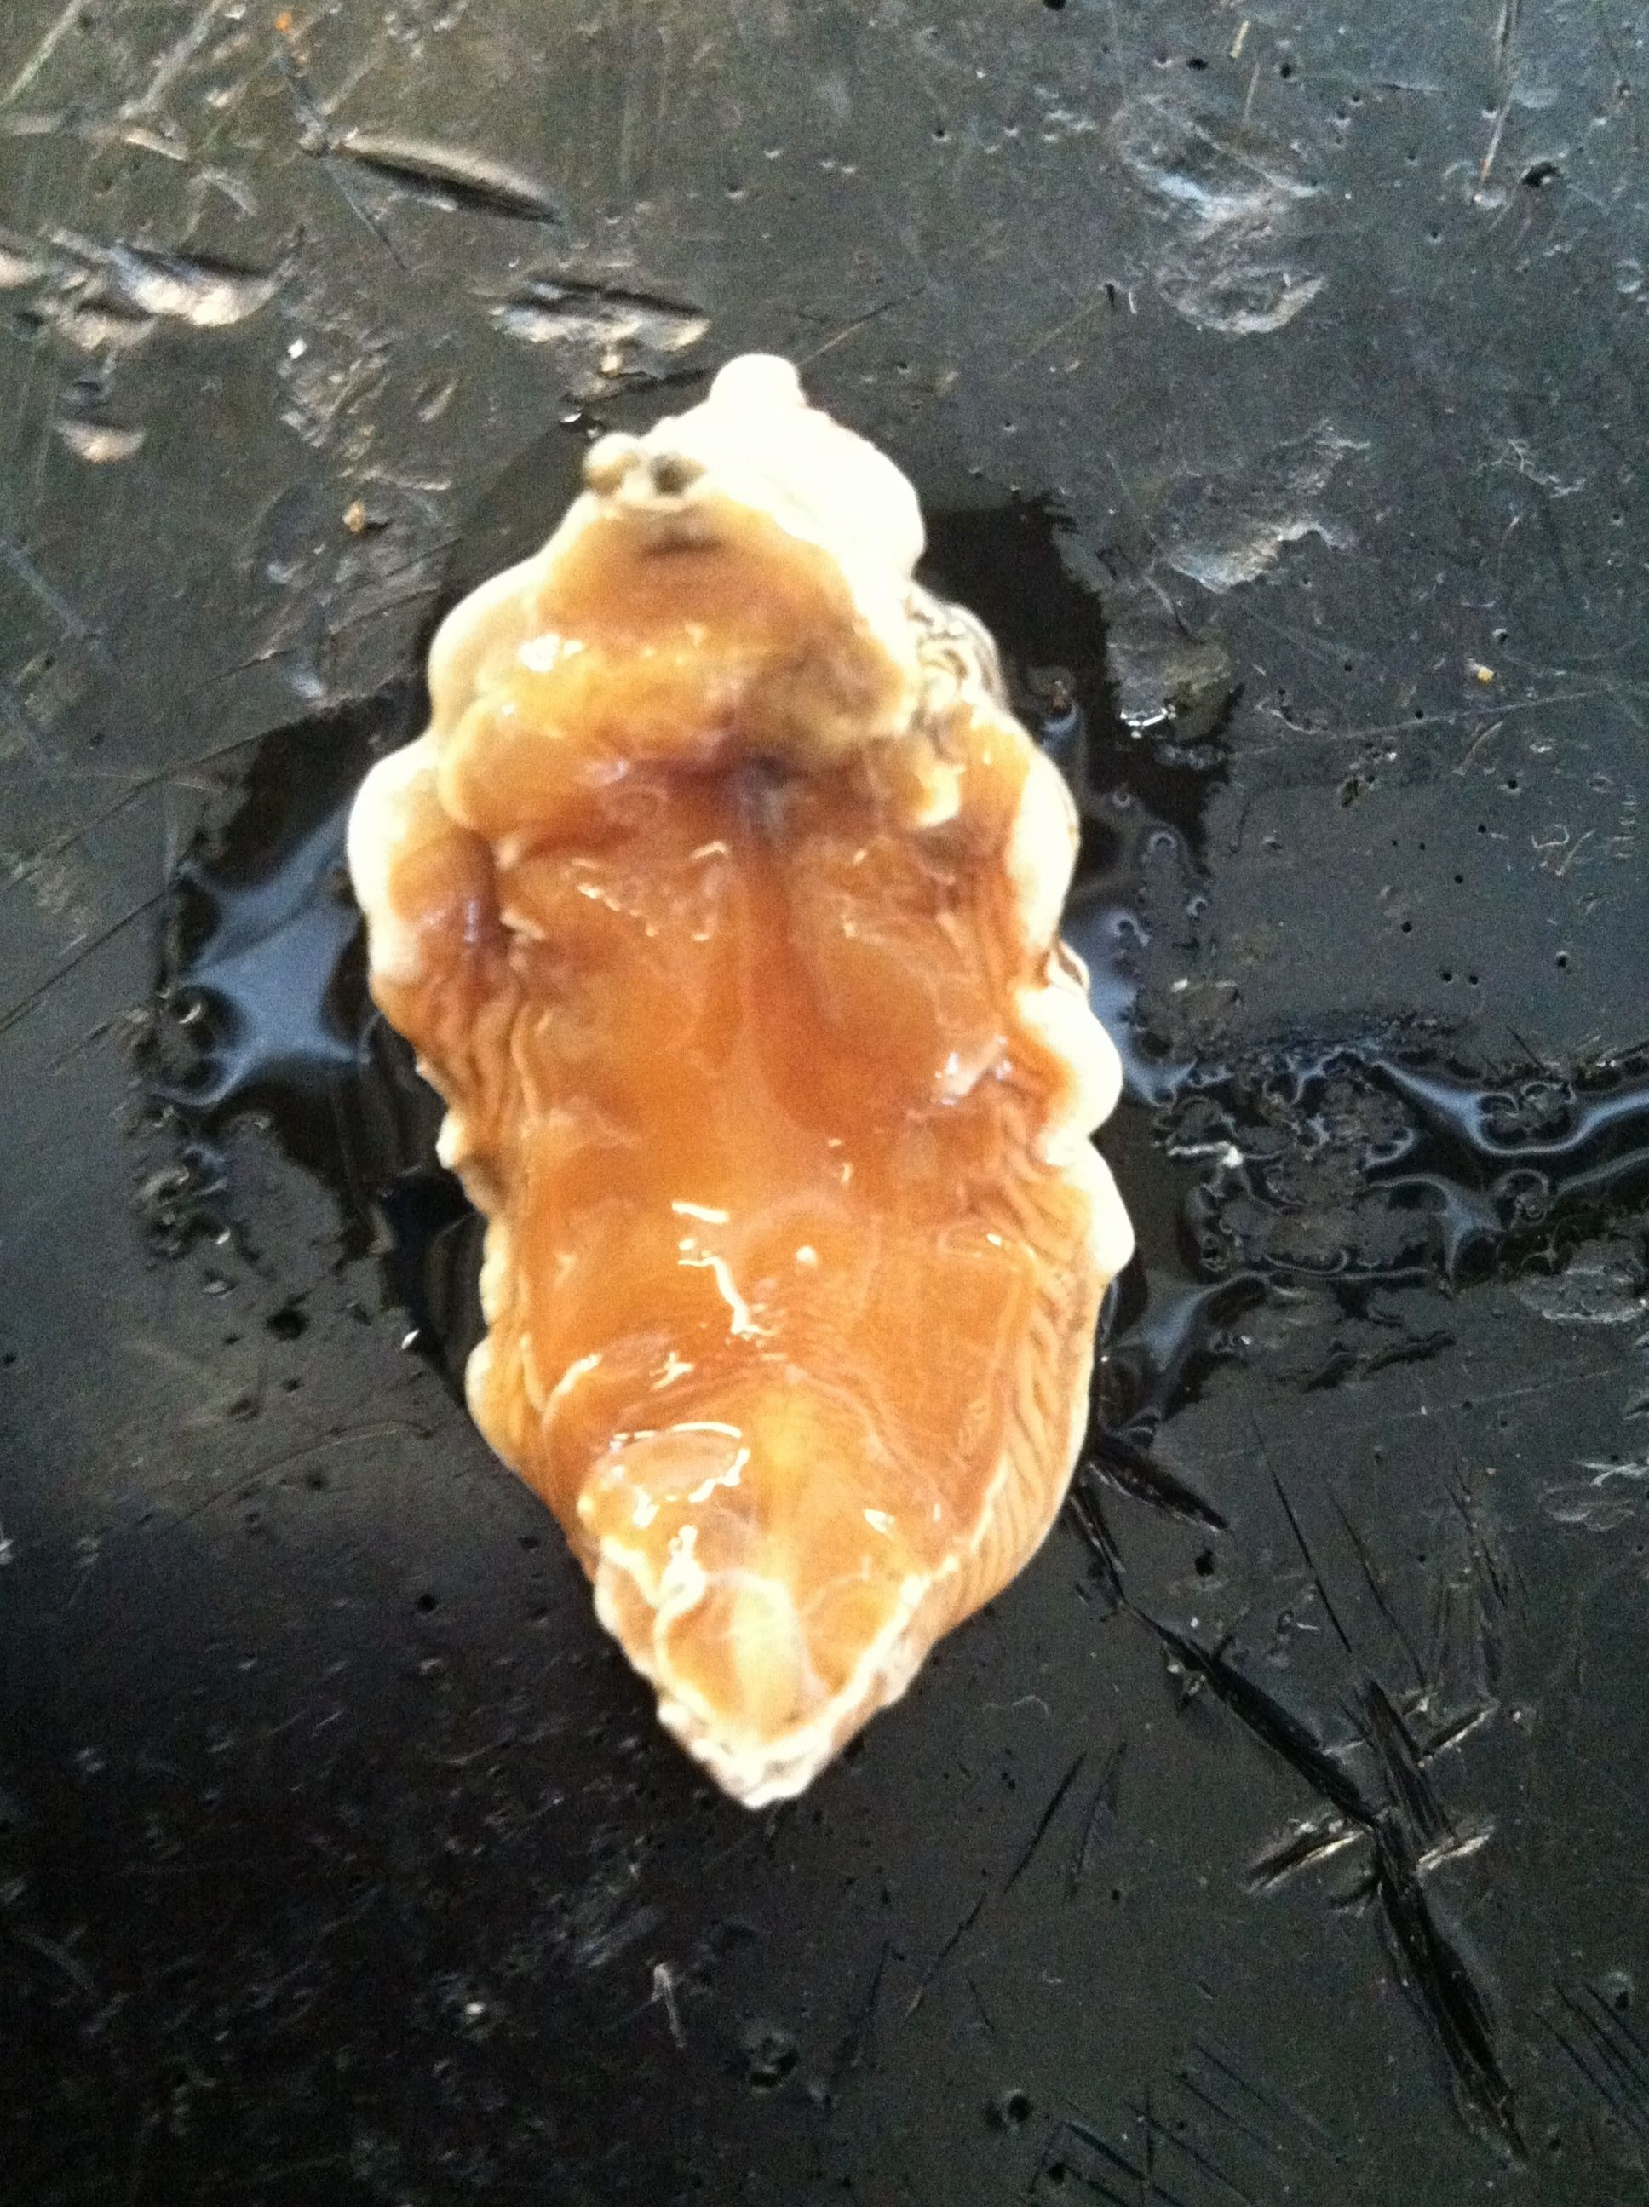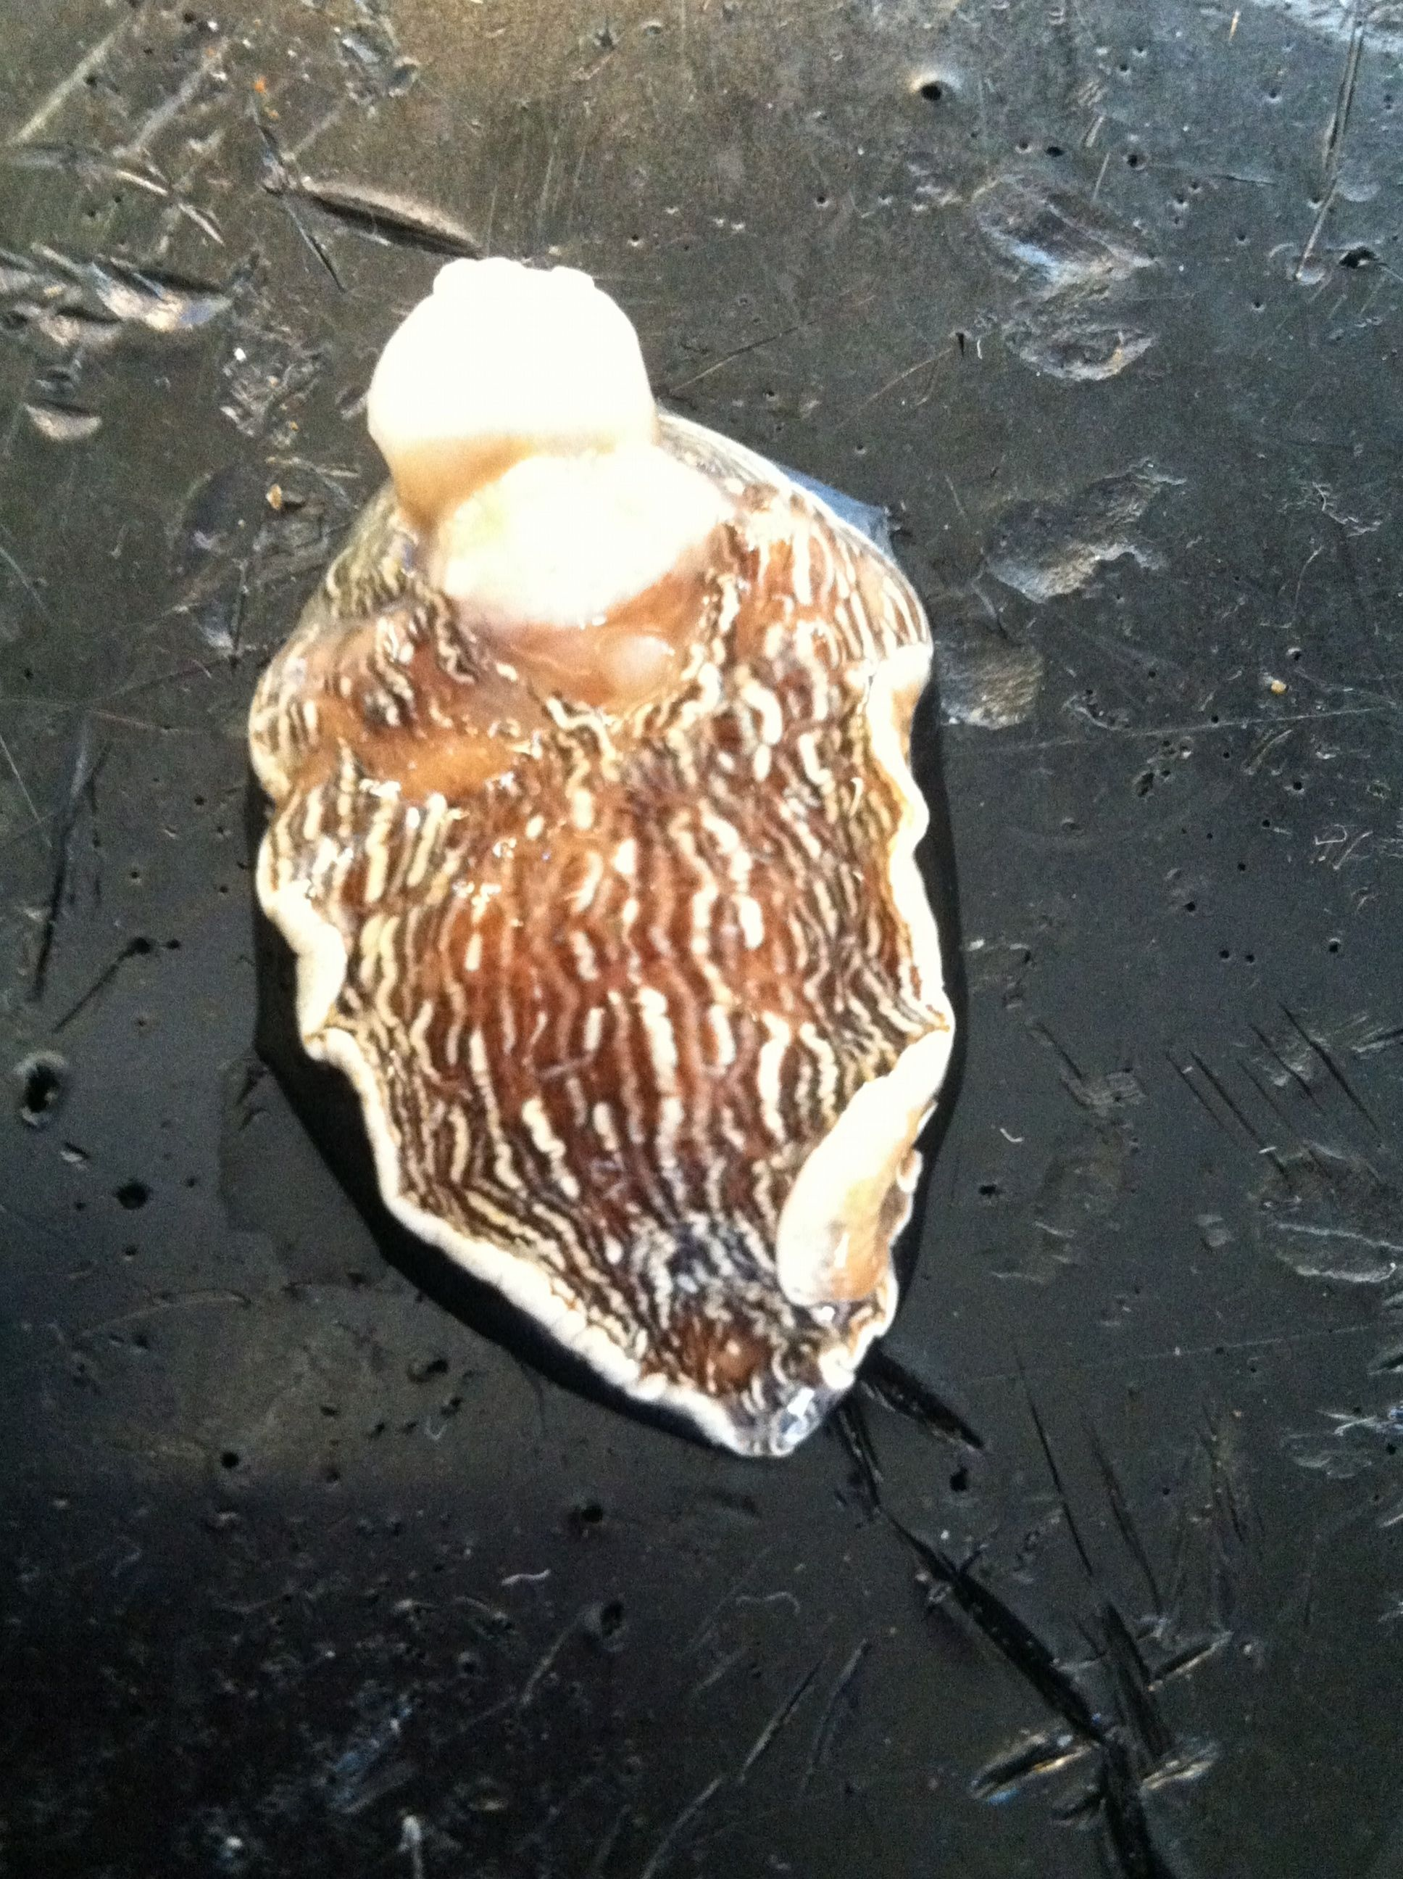

* *Armina* dissection-cut laterally on dorsal side near posterior end🡪digestive gland is large and orange

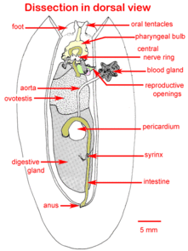

1. Cut piece size of eraser
2. Add biopsy sponge to close lid
3. Label cassete with accession # and using solvent resistant pen
4. Place cassete into invertebrate Davidson’s fixative for 24 hrs
5. After 2 hours cut off fixative and replace with 70% EtOH for long term storage

**7/26/12 DNA extraction and PCR**

Extraction of 12-1-3 and *Armina* skin lesion from 2010

Qiagen Stool kit🡪used to remove PCR inhibitors commonly found in digestive glands

1. Cut off a small piece of tissue-1/2 of eraser
   1. Weight the tissue and record in notebook
   2. Mince pieces in 2 mL microcentrifuge tube
2. Add 700 µl buffer ASL, vortex for 1 minute, add another 700 µl ASL. Vortex for 1 minute until sample is homogenize
3. Heat for 5 minute @ 70˚C
4. Vortex for 15s and centrifuge at full speed for 1 minute to pellet tissue
5. Pipet 1.2 mL of supernatant into new 2 mL microcentriuge tube. Discard pellet
6. Add 1 inhibit Ex table to each sample and vortex immediately and continuously for 1 minute or until table is completely dissolved. Incubate 1 minute room temperature to allow inhibitors to absorb into matrix
7. Centrifuge sample at full speed for 3 minutes to pellet inhibitors.
8. Pipet all supernatant into new 1.5 mL microcentrifuge tube. Centrifuge for 3 minutes (full speed).
9. Pipet 15 µl Proteinase K into new 1.5 mL microcentrifuge tube.
10. Pipet 200 µl supernatant from #8 into 1.5 mL microcentrifuge tube containing proteinase K.
11. Add 200 µl buffer AL and vortex 15s
12. Incubate at 70˚C for 10 minute
13. Briefly centrifuge. Add 200 µl of 95% molecular grade EtOH. Vortex 15s, briefly centrifuge.
14. Apply mixture to QIAamp spin column. Centrifuge 8000 rmp 1 minute
15. Place QIAamp split column in a clean 2mL centrifuge tube.
16. Add 500 µl AW1 buffer to spin column. Centrifuge for 1 minute
17. Discard collection tube and place spin column to new collection tube .
18. Add 500 µl AW2. Centrifuge for 3 minutes
19. Place spin column in final microcentrifuge tube. Add 100 µl buffer AE to column and allow to incubate at room temperature for 5 minutes. Remove spin column and throw it away
20. YAY DNA

3 primer sets

* Universal bacterial
* Ricketssia-Ehrichlichia-EHR16S
* WS-RLO RA 36/RA51

Generic

|  |  |  |
| --- | --- | --- |
| **Reagents** | **per rxn** | **5 rxns** |
| immomix | 12.5 | 62.5 |
| BSA | 1.5 | 7.5 |
| forward primer | 0.8 | 4 |
| reverse primer | 0.8 | 4 |
| H20 | 7.4 | 37 |
| template | 2 |  |
| total | 25 |  |

WS-RLO

|  |  |  |
| --- | --- | --- |
| **Reagents** | **per rxn** | **5 rxns** |
| 5x buffer | 4 | 20 |
| MgCl2 | 1.2 | 6 |
| BSA | 0.8 | 4 |
| H2O | 11.08 | 55.4 |
| dNTPs | 0.4 | 2 |
| RA36 | 0.1 | 0.5 |
| RA51 | 0.1 | 0.5 |
| Taq | 0.32 | 1.6 |

PCR conditions

|  |  |  |  |  |  |  |  |  |
| --- | --- | --- | --- | --- | --- | --- | --- | --- |
| Generic |  |  |  | WS-RLO |  | |  | |
|  | 95 | 10 min |  |  | 95 | | 3 min | |
| 45 cycles | 95 | 15 s |  | 40 cycles | 95 | | 1 min | |
|  | 60 | 1 min |  |  | 62 | | 30 s | |
|  |  |  |  |  | 72 | | 30 s | |
|  |  |  |  |  | 72 | | 10 min | |
|  |  |  |  |  |  | |  | |
|  |  |  |  |  | |  | |  | |

*PCR product taken off thermocycler cut can add holding step

7/27/12

Gel electrophoresis

1xTBE tris-HCL, boric acid, EDTA

SYBRSafe-10 µl

Pipet 7µl of weight ladder

Ladder-hyperladderIV-Bioline

10 bands, 100 bp-1013 bp Lot 1-14-111B

2 µl product of 5 µl of PCR product and into wells🡪 7 µl

Results-controls normal and general bacterial primer set positive, other 2 primers not positive

*Armina* skin lesion isolated from 2010 not positive