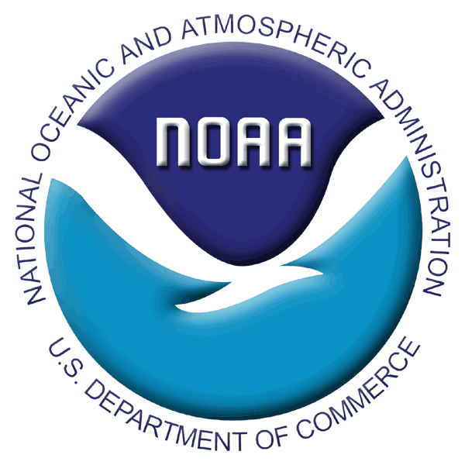

INSTRUCTIONS FOR 2008 RACE BOTTOM TRAWL SURVEYS

SPECIAL PROJECTS AND SCIENTIFIC COLLECTIONS REQUEST

During 2008, the RACE Division is planning to conduct three bottom trawl assessment surveys in Alaska, including the annual Bering Sea shelf crab and groundfish survey, the biennial Bering Sea upper continental slope groundfish survey, and the biennial Aleutian Islands groundfish survey. Although the occurrence and scope of these surveys is dependent on funding that has yet to be determined, we are planning as though all three surveys will be conducted in full. Special Project and Scientific Collection requests are REQUIRED for ANY and ALL sampling beyond the standard survey sampling methodology (including Special Projects and Scientific Collections proposed by RACE survey staff or other AFSC personnel).

Surveys are conducted aboard chartered fishing vessels where scientists are under heavy workloads with limited spare time to make additional collections. In light of this, Special Project and Scientific Collection requests will be accommodated to the extent that survey data quality is not compromised. Other considerations for accommodating requests are availability of shipboard space and personnel and ease of incorporation of the request into our standard survey sampling.

We are now considering requests for Special Projects and Scientific Collections for the upcoming 2008 late spring and summer field season. Due to the increasing number of requests received over recent years, it is unlikely that we will have the time or resources to accept all of the Special Project and Scientific Collection requests for the 2008 field season in Alaska. To better ensure that the highest priority requests are addressed, we are implementing new review requirements for the 2008 field season.

Requirements for AFSC Scientists: Special Project and Scientific Collection requests must be filed for ANY collections or at-sea sampling procedures that are beyond the standard survey sampling methodology. This includes ALL collections of age structures, stomachs, pathology specimens, hydroacoustic data, plankton samples, general specimen collections, etc. Note that no collections, for instance age structures, will be collected for ANY species unless they are requested through this process. AFSC scientists with projects fitting this definition need to fill out the Special Project and Scientific Collections Application form attached to this document in full. Each Division should review the applications from their respective programs and provide the Survey Coordinators in the RACE Division with a prioritized list of the requests from their division. Divisions should prioritize Special Project and Scientific Collection requests using the following criteria:

AFSC Mission Critical: This category should only include those Special Projects and Scientific Collections that are critical to the mission of the AFSC. This could include information critical to the stock assessment models for groundfish or crab species, critical process studies, or critical projects funded through reimbursable funds such as the NPRB BSIERP.

High Priority: This category should only include those Special Projects and Scientific Collections that are of high priority to studies by AFSC scientists but are not considered mission critical as defined above. Projects placed into this category should be additionally rated numerically from highest to lowest priority by each Division.

Low Priority: This category should include any remaining Special Project and Scientific Collection requests from AFSC scientists. This may include data requests for pilot or non-critical studies, requests that may be addressed through other means, or requests from long-term studies that may be addressed at a later date. Projects placed into this category should also be rated numerically from highest to lowest priority by each Division.

Each Division’s prioritized lists and associated applications for Special Projects and Scientific Collections must be submitted to our survey coordinators (identified on attached instructions) via email no later than COB 31 March 2008. No applications will be accepted beyond this deadline. Prioritized lists from each Division will be combined and reviewed to determine which Special Projects and Scientific Collections can be conducted in 2008 given the number and nature of the requests received and current budgetary constraints. If there is an issue in accommodating Critical or High Priority Projects, the RACE Division Director will consider the issues involved and, as necessary, will work with the Division leadership from the projects involved to resolve the conflicts. Additionally, the survey coordinators will work with requesters to refine project instructions to help reach project goals or if clarification is needed. Each requester will be informed of the status of their request before 18 April 2008. Supplies for accepted projects must be received at either AFSC Seattle or the Kodiak Lab by May 1. We will coordinate with scientists whose projects are accepted to ensure that all steps in the process are properly managed.

Requirements for non-AFSC Scientists: Non-AFSC scientists should note we only have a limited ability to address Special Project and Scientific Collection requests from researchers outside of the AFSC due to the demands for our vessel time and capabilities unless the project is of critical collaborative importance between the outside scientist/institution and AFSC. However, particularly for small requests, we will make every effort to meet your Special Project and Scientific Collection requests. Collaborative efforts, which engage the survey team as partners in conducting research and publication of results, will be given preference in the selection process. All research conducted through this program must be formally acknowledged, preferably by co-authorship when appropriate, in resulting reports, presentations, and publications.

Non-AFSC scientists wishing to place a Special Project and Scientific Collection request should fill out the attached Special Projects and Scientific Collections Application form in full and submit it to the Survey Coordinator(s) via email no later than COB 31 March 2008. Requests will be reviewed once they are received and staff will work with requesters if clarification is needed. Once reviewed, they will be prioritized to determine which Special Projects and Scientific Collections can be conducted in 2008 given the number and nature of the requests received and current budgetary constraints. Each Requester will be informed of the status of their request before 18 April 2008. Supplies for accepted projects must be received at either AFSC Seattle or the Kodiak Lab by May 1. We will coordinate with scientists whose projects are accepted to ensure that all steps in the process are properly managed.

Instructions for Filing a Special Project and Scientific Collections Application Form
(MUST BE COMPLETED IN FULL)

- The title of the Special Project and the Principal Investigator's contact information including affiliation, postal mailing address, email address, and telephone number.

- How is the project relevant to NMFS mission goals or milestones?

- General description and justification for the special collection.

- Detailed description of collection procedures and list of special forms and equipment that will be required. Be as specific as possible and include the desired sampling location(s). Applicant must provide a draft of the instructions (using the template format) for the Operations Manual, and an example of any special data forms. (NOTE: If project involves participation in the survey, describe the extent of participation and how collection procedures can be incorporated into our standard sampling methodology without compromising survey data quality. If planning to participate on our survey how will any associated travel costs or overtime costs, if appropriate, be covered?).

- List of supplies. The person making the request must provide or arrange for all collection supplies, including chemicals (EtOH and Formaldehyde can be provided in small quantities, but applicants must arrange this specifically with survey coordinator(s) prior to the start of the survey).

- A metadata record containing your project title, name and contact information from your submission form will be included in the database regardless of which of the following options you choose. This will allow for a permanent connection between your project and a Groundfish Survey vessel and cruise.
There are three options for relating your special project data to the NMFS/AFSC Groundfish database:
i. You have no requirement to store data in the Groundfish database and no need to relate data later to haul level data (e.g. haul position, depth, trawl temperature):
No action needed.
ii. You have no requirement to store data in the Groundfish database, but would like relate your data to haul level data:
No Groundfish Group action needed, but your data should be collected including Vessel, Cruise and Haul numbers to produce a complete data key to relate the data. With this information, you can permanently link your specimens to haul level data.
iii. You would like to store data in the Groundfish Database.
Candidate data for the Groundfish Database must meet strict data requirements and the data must conform to Groundfish Database data field rules. The most common type of data that will fit in the Groundfish Database model are specimen type data (specimen number, weight, length, gonad weight; a few other unspecified numeric parameters can be stored). Specimens with age structure collections will fall into this category. If you would like to have data considered for inclusion in Groundfish Database, contact Robin Harrison (robin.harrison@noaa.gov - Phone: 206-526-4139) for the requirements document before submitting your application form. You will need to provide a complete description of your data, which will be reviewed for suitability for inclusion in the database.

- Hazardous Material Instructions: Provide MSDSs and Standard Operating Procedures for all hazardous materials to be used (NOTE: use of HAZMAT is discouraged because of the restrictions and limitations for shipping).

- Contacts and phone numbers of someone available 24/7 to discuss logistics and problems or authorize billings at the anticipated time of shipment (i.e., end of leg and end of survey).

- Instructions on how to ship samples. The person making the request will pay for all charges associated with shipping and storage including the following: 1) completed shipping company forms with the shipping account number or a credit card number; 2) collection and shipping containers with any additional packing materials like zip lock bags; 3) if samples are frozen, coolers or commercial waxed boxes must be provided. The RACE Division, Seattle or Kodiak, must receive supplies and containers no later than May 1.

- It is the responsibility of the person making the request to obtain all the necessary permits required for the collection and shipment of specimens, and the RACE Division must have copies of the permits no later than May 1.

- For AFSC scientists, completed forms must be emailed to their respective division directors for evaluation and prioritization PRIOR to the to the March 31, 2008 survey deadline. AFSC scientists should contact their division director for divisional submission deadlines. Non-AFSC scientist requests must be emailed to the survey coordinator for the survey of interest prior to the March 31 deadline using the email addresses provided below.

If you have any questions please contact the survey coordinator(s) for the survey(s) you are interested in:
Bering Sea Shelf: lyle.britt@noaa.gov Ph. (206) 526-4501 (groundfish)
jan.a.haaga@noaa.gov Ph. (907) 481-1718 (crab)

Bering Sea Slope: jerry.hoff@noaa.gov Ph. (206) 526-4580

Aleutian Islands: mark.wilkins@noaa.gov Ph. (206) 526-4104
jim.stark@noaa.gov Ph. (206) 526-4155
SPECIAL PROJECT AND SCIENTIFIC COLLECTIONS APPLICATION FORM

2008 RACE BOTTOM TRAWL SURVEYS

(Please read attached INSTRUCTIONS for details!)

Submission Deadline: March 31, 2008

- Project Title:
Principle Investigator (PI)/Point of Contact:
Affiliation:
Address:
Email: Phone:

- History of work with AFSC RACE Division
  - Past Special Projects with RACE:
  - Priorities proposed project relates to:
  - RACE collaboration:

- General Description and Justification:

COLLECTION PROTOCOL
- Detailed collection procedures:
- List of supplies:
- Needs for Data Storage by the AFSC RACE Division:
- Hazardous materials:

SHIPPING
- 24/7 contact:
- Detailed shipping instructions:
[NOTE: FedEx next-day shipping imposes some complications. If you are requesting this method of shipping, please make sure to plan carefully with the special project coordinator.]

PERMITS
- Permits issued or pending:

