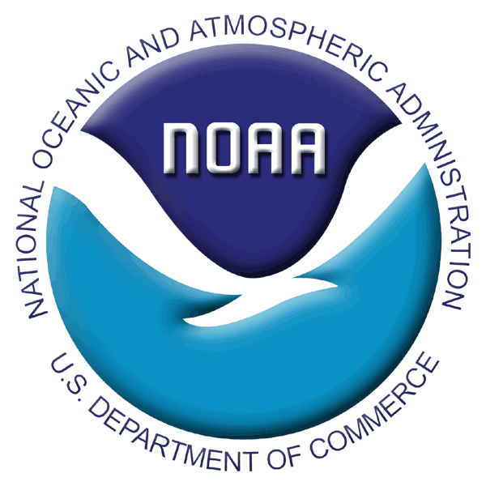

INSTRUCTIONS FOR 2006 RACE BOTTOM TRAWL SURVEYS

SPECIAL PROJECT PROPOSAL

Aleutian Islands: jim.stark@noaa.gov Ph. (206) 526-4155
or mark.wilkins@noaa.gov Ph. (206) 526-4104
SPECIAL PROJECT APPLICATION
2006 RACE BOTTOM TRAWL SURVEYS

- Project Title: Identification of parasites of cephalopods
Principle Investigator (PI)/Point of Contact: Elaina Jorgensen, Frank Morado, Pam Jensen
Affiliation: RACE
Address: 7600 Sand Point Way NE Seattle, WA 98115
Email: elaina.jorgensen@noaa.gov , frank.morado@noaa.gov , pam.jensen@noaa.gov Phone: 526-4562 (EJ), 526-6572 (FM) 260-543-9297 (PJ until April 1st), 526-4122 (PJ after Apr 1st)

- History of work with AFSC RACE Division
  - Past Special Projects with RACE: yes
  - Priorities proposed project relates to: ecosystem dynamics

Priority | Project | NMFS Activity | NMFS Program Capability
Species/Population Identification | DNA-based identification of pathogens and parasites | Recovery Implementation & Mangement Actions for Marine Mammals | Protected Species - Recovery Implementation & Mangement Plan
Organism/Ecosystem Health | Parasites as indicators of ecosystem health/change. | Ecosystem Structure & Function Surveys | Ecosystem Monitoring, Assessment & Forecasting

  - RACE collaboration: Jorgensen, Morado, Jensen, Troy Buckley (REFM), Kerim Aydin (REFM), Bobette Dickerson (NMML), Lorenz Hauser (Univ Wash)

- General Description and Justification: Parasites will be collected from cephalopods & preserved in ethanol during the Aleutian Islands survey for morphological and DNA-based identification at AFSC as part of a larger collaborative study (RACE, REFM, NMML, UW) on movement of parasites through marine trophic levels.

COLLECTION PROTOCOL
- Detailed collection procedures: During the Aleutian Islands survey, Elaina will dissect out parasites as she encounters them in specimens collected that she is dissecting for her cephalopod research.
- List of supplies: Elaina will provide supplies (dissection kit, vials, ethanol, data sheet). Example of data sheet is included.
- Hazardous materials:100% ethanol (approx. 2 L total, 140 x 15ml otolith vials in 1 box)
- Time Requirement: 15-30 min whenever cephalopods are encountered and collected.

SHIPPING
- 24/7 contact: Pam Jensen
- Detailed shipping instructions: Will use AFSC shipping van to and from Alaska.

PERMITS
- Permits issued or pending: ADF&G Fish Resource Permit # CF-06-008 Exp. 12/31/2006

