Project Report
PSMFC Subaward 23-084G for the period August 1 through October 31 2024

Project Title: Gene activity and genetic selection in Pacific cod reared under thermal stress

Objective: Predict organismal and population outcomes of Pacific cod exposed to elevated temperature

Summary: Recent heat wave stress in the Gulf of Alaska has resulted in significant declines of Pacific cod, Gadus macrocephalus, in that region. The physiological and transcriptional responses of Pacific cod and whether selective mortality is present under thermal stress are unknown. The proposed project will address these questions critical to their survival under climate change by identifying regions of the genome and epigenome that respond to thermal stress. Juvenile Pacific cod will be reared in several temperatures then an integrated genomic approach will identify genes, gene variants, and epigenetic markers that respond to thermal stress and confer resilience. To complement the genomic approaches and further investigate temperature influences on energy resources, we will perform lipid analyses. This work will inform predictions of genetic selection and molecular response of Pacific cod in the Gulf of Alaska under climate change.
Progress and results
Brief Summary: Progress includes successful genetic assignments of experimental fish to the western Gulf of Alaska/Eastern Bering Sea group, enabling the study of regional responses to temperature. Lipid analyses showed that energy storage peaked at 9°C, while the highest temperature (16°C) led to decreased triglyceride levels, critical for overwinter survival. Growth studies confirmed an optimal temperature for growth at 12.3°C, aligning with the lipid findings. Gene expression analysis revealed significant changes in genes related to energy production, immune function, and lipid metabolism under varying temperatures, with both cold and warm extremes impacting energy balance. The integration of phenotypic and genomic data aims to identify specific genes linked to resilience, though limited sample sizes challenge broader conclusions. Ongoing efforts focus on refining these findings despite technical hurdles in DNA methylation extraction. A detailed report of activities is provided below

Genetic analyses: During this reporting period we finished genetic analyses to determine the likely origin of our wild-caught experimental fish. We leveraged previously collected genetic data from over 600 adult Pacific cod of known spawning origin, and developed a tool that uses genetic data from ~6,000 sites on the Pacific cod genome to assign wild-collected fish to one of four major spawning aggregations, the Northern Bering Sea (NBS), Aleutian Islands (AI), Eastern Bering Sea / western Gulf of Alaska (EBS/wGOA), and eastern Gulf of Alaska (eGOA). All experimental fish were assigned to the wGOA / EBS spawning aggregation (Figure 1). Our study therefore characterizes the level of plasticity and inter-individual variability of juveniles from wGOA/EBS cod under varying thermal conditions.
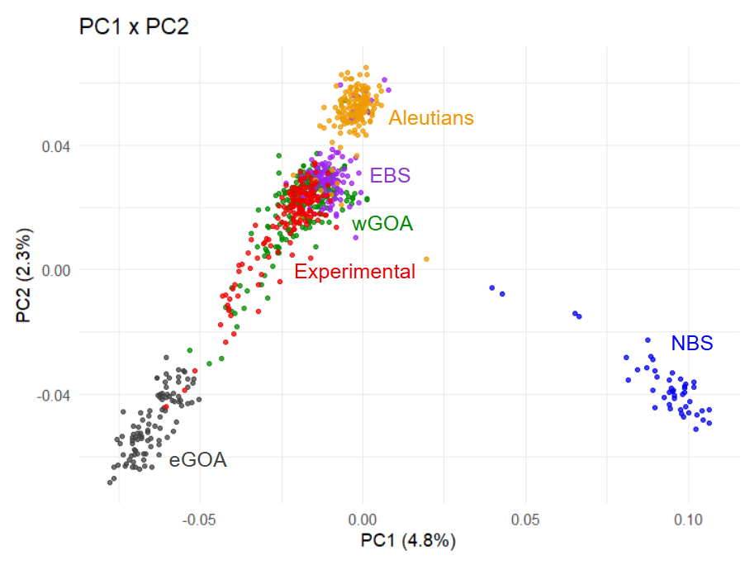
Figure 1: Principal component analysis showing genetic composition of experimental animals (red) in relation to the genetic structure of major Pacific cod spawning aggregations. Experimental fish were assigned the western Gulf of Alaska (wGOA, green) / Eastern Bering Sea (EBS) spawning aggregation.

Lipid analyses: Co-PI Louise Copement (Hatfield Marine Science Center) completed measurements of liver lipid components for a subset of experimental fish (25 from each temperature treatment), including triglycerides, fatty acids, sterols, polar lipids, and total lipid content. This data was analyzed for differences among temperature treatment to assess effects of temperature on juvenile Pacific cod energy allocation and liver lipid profiles. Energy allocation in experimental cod peaked at 9°C, and was lowest in the warmest temperature tested (16°C) (Figure 2). This effect was largely driven by triglyceride content, which is the primary energy storage and is critical to overwintering survival. Similar patterns were observed in free fatty acid content, which is used as an immediate energy source.

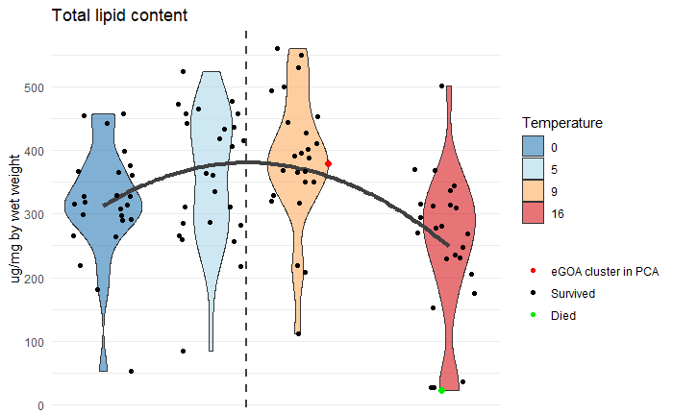
Figure 2: Total lipid content measured in juvenile Pacific cod livers after experimental exposure to four temperatures (0°C, 5°C, 9°C, and 16°C).

Growth and condition: New analyses were performed to model temperature-dependent growth rates based on standard lengths and wet weights, which both predicted optimal growth rates for our experimental fish (T_{max}) at 12.3°C (Figure 3), which is slightly higher than reported in Laurel et al. 2015 (T_{max}=11.5°C).
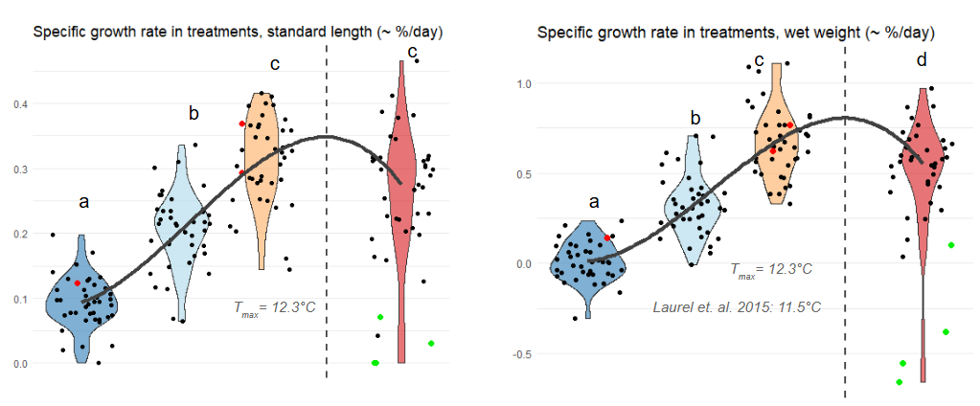
Figure 3: Specific growth rates (SGR) based on standard length (left) and wet weight (right)

Gene expression analyses: We received additional liver RNASeq data from the sequencing facility. This was in response to our request based on preliminary analyses indicating that data quantities did not meet contracted amounts. Upon receiving this new data, it was merged with the original RNASeq data and fully re-analyzed using updated code. Revised analyses with augmented data increased power to detect differences in gene activity among treatments, but did not affect overall conclusions. Broadly, preliminary results show major transcriptional changes in liver tissue in response to warming that involve energy usage and production, immune function, lipid metabolism, cell adhesion, cell cycle and division, and protein production.
We also expanded our gene expression analyses to identify genes that respond to temperature nonlinearly, akin to the temperature-dependent growth responses (Figure 2), which are involved in fatty acid metabolism, immune function, cell proliferation, and protein production localized primarily at mitochondria. These preliminary results suggest that energy availability and ATP production (the primary cellular energy source) is negatively impacted by suboptimally cold and warm conditions.

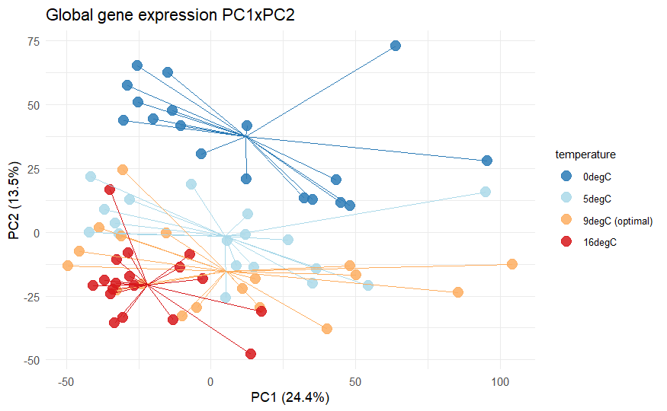
Figure 4: Major gene expression differences among juvenile Pacific cod exposed to 0°C, 5°C, 9°C, and 16°C (measured in liver tissue) indicate large effects of temperature, which were largely related to energy production, lipid metabolism, and immune function.

Broadly, the lipid, growth, condition, and gene expression analyses indicate that suboptimal temperatures will reduce wGOA/EBS juvenile Pacific cod energy storage which will likely impact recruitment levels due to reduced overwintering survival.

Data set integration: We have begun integrating phenotypic and genomics data to identify genes, their functions, and possibly genotypes that are associated with high growth and lipid storage in response to each temperature. This will enable insight into Pacific cod populations or individuals that are better equipped for suboptimal temperatures, and will help guide population-genetics studies that have thermal adaptation questions. Typically, genotype association studies, which identify variants/alleles that likely affect a phenotype, require large sample sizes and high-confidence genotype calls. Due to our smaller sample sizes we are interrogating a portion of the genome. Specifically, we are leveraging the gene expression data to identify protein-coding genes regions that are temperature-responsive, and which are correlated with performance metrics (growth rate, lipid storage). This considerably reduces the dataset and number of comparisons, improving our power to detect high-effect loci in functional regions of the genome.
The genotyping aspect of these analyses continues to be challenged by the amount of genetic data in hand for each sample. High-confidence genotype calls require appr. 10+ sequences per locus (i.e. 10x depth), whereas we have genotype probabilities derived from low-depth loci (ave. 3x depth). We are currently extracting genotypes from RNASeq data to determine whether genotypes can be generated from sufficient samples across genes of interest. This will dictate whether we are able to use data in hand to conduct the association studies, and whether additional sequencing is necessary to augment existing genetic data.

Challenges
DNA methylation extraction process need to be further optimized to improve quantity and quality.

